lernOS Podcasting Guide

Sharing knowledge with podcasts and VLogs

Simon Dückert

Version 0.9 (02/27/2022)

***ATTENTION:*** *this version was translated by a machine (Office 365) not a human. It may contain silly translations.*

Table of Contents

1About lernOS 2

2Basics 3

2.1Podcasting Canvas 4

2.2Format 6

2.2.1 Gesprächspartner_innen 6

2.2.2Mission length and frequency 7

2.2.3Content and form 7

2.2.4Media such as intro, outro and jingles 8

2.3Workflow 8

2.4Hardware 9

2.4.1Microphones and headsets 10

2.4.2Audio recorders 12

2.4.3Audio interfaces and mixing consoles 12

2.4.4Audio Processing 14

2.5Software 14

2.5.1Ardour 15

2.5.2Audacity 15

2.5.3Audition 16

2.5.4Ferrite 17

2.5.5Garage tape 18

2.5.6Hindenburg 19

2.5.7Reaper + Ultrasound 19

2.5.8Studio Link Standalone 20

2.5.9Zencastr 21

2.6Studio 22

2.6.1Room situation and reverb 22

2.6.2.Speaker position 23

2.6.3Microphone 23

2.7Literature and Links 23

3Podcasting Learning Path 24

3.1Get Started (Kata) 25

3.2Choose a podcast app and find podcasts (Kata) 25

3.3Use the Podcast Canvas as a checklist (Kata) 27

3.4Take up your "zero number" 28

3.5Di Podcast Studio (Kata) 29

3.6Attention Recording Episode 1 (Kata) 30

3.7Your podcast website (Kata) 33

3.8Attention Recording Episode 2 (Kata) 36

3.9Publize your episodes (Kata) 37

3.10Communication, Communication, Communication (Kata) 37

3.11Podcast Clinic (Kata) 39

4Attendix 41

4.1List of materials 41

4.2Thanks 42

4.3Change history 43

# 1About lernOS

lernOS is a method of self-organization for people who live and work in the 21st century. To be successful today, you have to constantly learn, organize and develop. No one else is responsible for this process. You have to take care of it yourself (self-directed, lifelong learning).

The trend Working Out Loud means to make one's own work visible and to tell about one's own work in order to enable networking and to receive help from the network. Internal and external social networks are often used as a platform. Especially when it comes to transporting knowledge to complex topics or emotions, short texts are often not enough. Audio and video formats such as screencasts, explanatory videos and podcasts are better suited here.

Podcasts have the advantage that they are much easier to produce than videos. In addition, podcasts can be consumed in places where the use of videos is difficult (commuters, in the car, on the plane, while walking, etc.). With this lernOS guide you will learn to make and publish your own podcast in a learning sprint . You can go through the podcasting learning path alone or in a learning circle with 4-5 other people.

@simondueck ert

License

lernOS guides are licensed under the [Creative Commons Attribution 4.0 International](https://creativecommons.org/licenses/by/4.0/deed.de) (CC BY 4.0) license:



**You may:**

* **Sharing - reproduce** and redistribute the material in any format or medium.
* **Edit** - remix, modify and build on the material for any purpose, even commercially.

**Under the following conditions:**

* **Attribution** - You must provide appropriate copyright and rights information, attach a Link to the license, and indicate if any changes have been made. This information may be provided in any reasonable manner, but not in such a way as to give the impression that the Licensor specifically supports you or your use.
* **No further restrictions** - You will not use additional clauses or technical procedures that legally prohibit others from anything that the license allows.

# 2Basics

Tim Berners-Lee put a website online on 13.11.1990, which today is officially considered [the first weblog](https://de.wikipedia.org/wiki/Blog). In 1997, Dave Winer started his blog Scripting News. In the same year, the term "weblog" was used for the first time. Weblogs put their content above sog. [RSS feeds](https://de.wikipedia.org/wiki/RSS_(Web-Feed)) are available in machine-readable form.

Dave Winer was the first to use weblogs and RSS feeds in 2000 for the first practical implementation of a [podcast](https://de.wikipedia.org/wiki/Podcast) , which at the time were still called audio blogs. Apple gave podcasts their name used to this day with the release of the iPod in 2005.

In addition to the audio blogs, the [video blogs](https://de.wikipedia.org/wiki/Vlog) (vlogs) were also created in 2004, which have become well known through the company YouTube, founded in 2005. Unlike mass media such as newspapers, radio or television, podcasts offer much more freedom in format choice and interaction with the listener community.

Podcasts could thus represent a "communication apparatus" that Berthold Brecht already explained in his [radio theory](https://de.wikipedia.org/wiki/Radiotheorie) in the 1930s:

Broadcasting would be the greatest conceivable communication apparatus of public life, a tremendous channel system, that is, it would be if it knew how not only to broadcast, but also to receive, i.e . not only to hear the listener, but also to make him speak and not to isolate him, but also to relate him.

Making your own radio is easy. You should only think in advance about how many people you want to talk to in which situation, what requirements you place on the quality and mobility of the technology and, above all, how to shape the conversation will. The first attempts will certainly be catastrophic, but that is changing quickly. Every podcast owner looks at his first show with a latent discomfort, often also the second. But from then on you quickly gain experience and routine. If you stick to it, you will quickly come to passable and satisfying results.

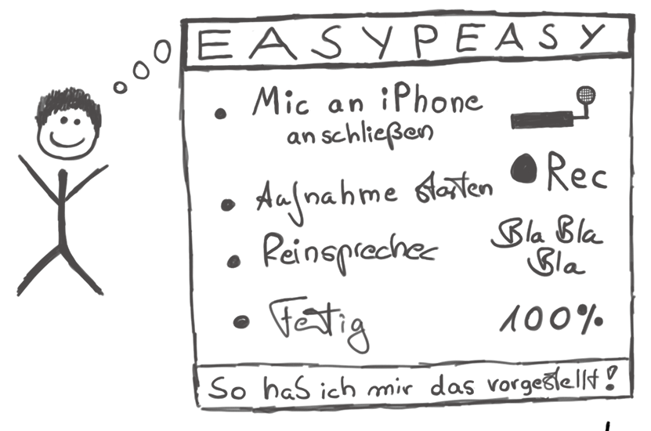

Original image: Marco Hitschler on zirkusliebe.de, CC BY, <https://www.unmus.de/podcast-in-a-nutshell/>

The desire to produce audio broadcasts in the form of podcasts poses some questions for many newcomers:

1. Which format is the right one?
2. What audio technology do I need to perform, edit and publish recordings in appropriate quality?

The answer to these questions depends on many factors:

1. Who is the target group?
2. How many people are involved in the podcast?
3. In which room or situation should the recordings be made? How portable does the equipment have to be?
4. Should the broadcast be broadcast live?
5. Should people be included in the broadcast by phone?

In order to be able to answer these questions well and make the right decision, the Podcasting Canvas is presented below, a kind of visual checklist with which all questions relevant to your own podcast can be asked and answered.

## 2.1Podcasting Canvas

The lernOS podcasting canvas provides an overview of the most important design fields of a podcast. For a complete podcast concept, all fields should be filled with content. To work with the canvas, it can be printed out or used electronically (e.B. in a whiteboard).

**Tip:** Since the ideas around a podcast often change at the beginning, you should not label the canvas, but work with more flexible sticky notes.

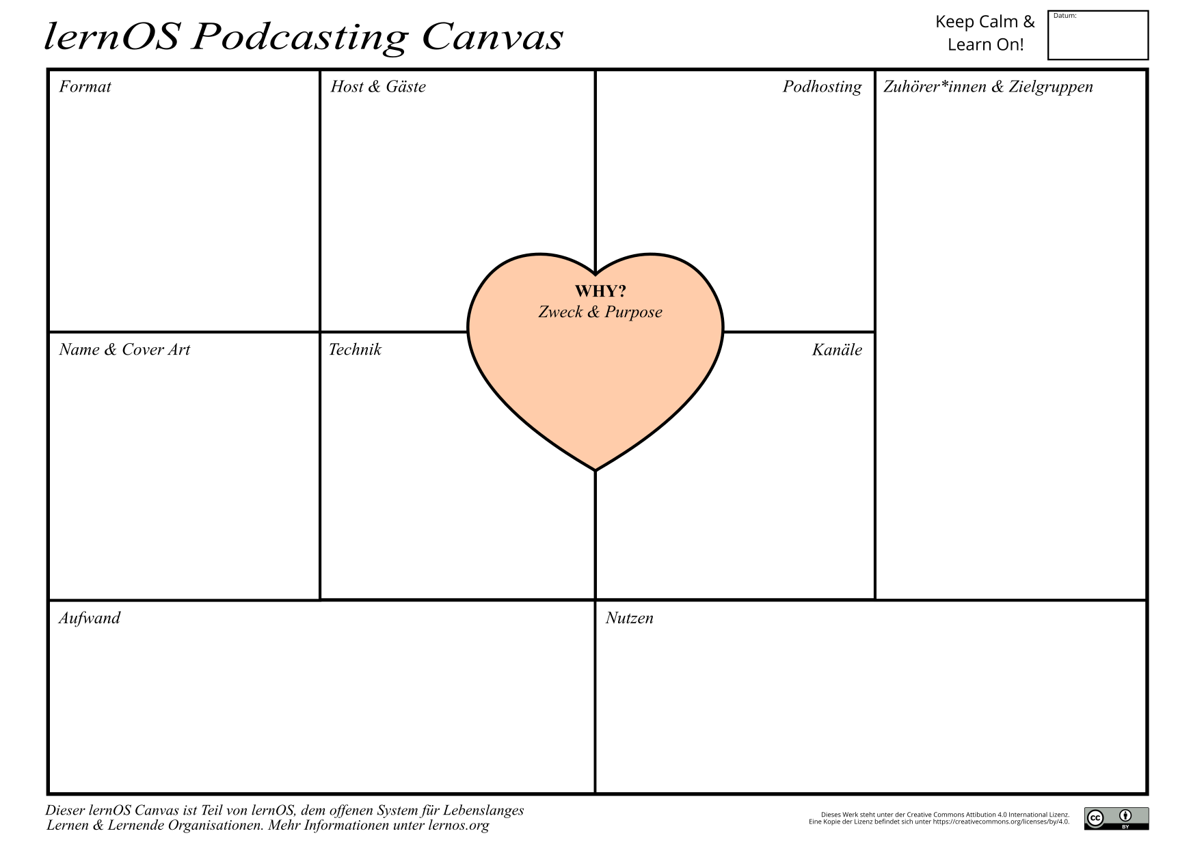

These are the fields of the lernOS Podcasting Canvas (in the suggested order of editing):

1. **Why? Purpose & Purpose:** Why do you really, really want to do the podcast? What is the purpose of the podcast? Why is the podcast important to you?
2. **Listeners & Target Group:** What are the podcast's target groups? Who should listen? What motivates the target group to listen?
3. **Format:** What form should the podcast have? What genre does the podcast belong to? What is the content? Which people are talking? How often does the podcast appear? How long is it?
4. **Name & Cover Art:** What should the podcast be called? What should the cover art look like (size: 3000x3000px)?
5. **Host & Guests:** Who is the host? Who are regular participants? Should there be guests?
6. **Technology:** Which hardware is used for production (audio recorders, audio interfaces, microphones, etc.)? What software is used for recording, remote podcasting, live recording and editing?
7. **Podhosting:** Where should the podcast's media files be delivered? On the Internet or on the intranet? Own hosting or cloud service?
8. **Channels:** On which channels is the podcast published (RSS feed, Spotify etc.) and communicated (social media, Twitter, etc.)?
9. **Effort:** What effort arises from the conception above (time & money)?
10. **Benefit:** What are your benefits from the podcast? Does the benefit justify the effort? Is the podast a hobby (corporate hobby) or part of the work task or does the podcast have to refinance itself (e.B. sponsoring, donations, advertising)

## 2.2Format

The format of the sendung is the primary design decision of a podcast. How many people are participating? Who takes on the role of a moderator? How can, should and may a broadcast be? All these parameters have an influence on the technology and no technical constellation is suitable for every situation. Therefore, it makes sense to think about the directions in which the podcast should and could develop before starting. The following is a description of typical podcast formats.

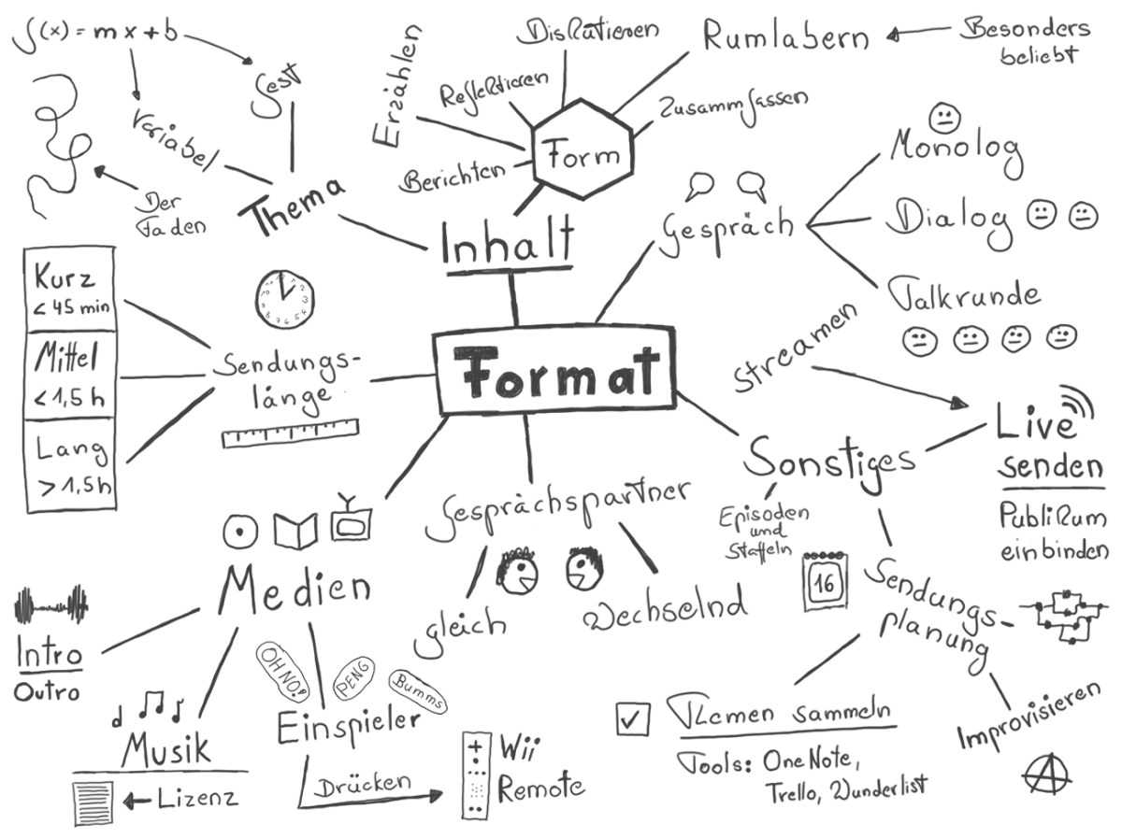

Original image: Marco Hitschler on zirkusliebe.de, CC BY, <https://www.unmus.de/podcast-in-a-nutshell/>

### 2.2.1 Gesprächspartner_innen

The Gesprächspartner_innen in the podcast can remain the same or change across the episodes (shows). Depending on the number of interlocutors, a distinction is made:

* **Monologue or solo podcast:** In a solo podcast, only one person speaks. Listening to monologue podcasts can also quickly become straining for the listener, as pauses and speed changes are rare, which could give the listener a breather and variety. Solo podcasts can be realized with relatively little technical effort, as only a microphone and no live switching are required. For recording, a simple software with recording function can be taken (e.B. Audacity).
* **Dialogue or interview podcast:** If a program is recorded with two people, the dynamics of the conversation usually change significantly. It is irrelevant whether the two persons act as moderators on an equal footing or whether it is a moderator/guest situation. The natural pauses of a reciprocal conversation or the transition between two separate speeches create a significantly different format for the listener from the solo podcast. To record a dialogue podcast, the technical requirements are slightly higher: two voices must be recorded in a separate audio track. At
* **Talk or discussion round:** With three or more participants, a conversation quickly develops into a dynamic discussion round, which on the one hand can be very entertaining, but also makes it increasingly difficult for the listener to follow the individual speakers or identify them (more than six people are rather uncommon in podcasts). One way to increase the comprehensibility of a large discussion round is to position each speaker in the stereo image in a different place (max. 20% right/links).

### 2.2.2Mission length and frequency

The "right" length for podcasts does not exist, podcasts can have any length appropriate to the purpose of the podcast. Often the duration of a domestic flight (30-45 minutes) is mentioned as the optimal length. Roughly speaking, three categories of podcast lengths can be distinguished:

* **Short podcasts** are less than 45 minutes long
* **Medium-length** podcasts are between 45 and 90 minutes long
* **Long podcasts** are longer than 90 minutes (up to several hours)

Auch the frequency with the podcast episodes can be very different. The podcast can appear regularly (e.B. weekly, monthly) or irregularly (depending on the occasion).

### 2.2.3Content and form

When it comes to the content design of podcasts, there is no limit to phantasy. Any topic that interests a group of people can lend itself to a podcast. Podcast episodes can cover one topic (monothematic) or multiple topics. Podcasts can also deal with current topics (News podcasts) or timeless topics (evergreen). A good orientation to topics of podcasts is e.B. the podcast directory of Apple:

* Art
* Economy
* Comedy
* Education
* Fiction
* Government
* Health & Fitness
* History
* Children and family
* Leisure
* Music
* News
* Religion and Spirituality
* Science
* Society and culture
* Sport
* TV and film
* Technology
* True criminal cases

### 2.2.4Media such as intro, outro and jingles

Similar to radio or TV shows, podcasts can have music at the beginning (intro) and at the end (intro), but they don't have to. Some podcasts also use the intro to take a look back at the past show (the "Previously") or to tease a quote from the current episode.

During an episode, so-called "jingles" can be recorded in the podcasts. This can be e.B. advertising or short melodies. If a podcast has different thematic sections, they can be separated from each other by short jingles.

Free sounds and music are available e.B at the following places (pay attention to licenses and usage rights):

* [BBC Sound Effects](https://sound-effects.bbcrewind.co.uk)
* [Free Music Archive](%5BFree%20Music%20Archive%20-%20Welcome%20to%20the%20Free%20Music%20Archive%5D(https://freemusicarchive.org/home))
* [YouTube](https://youtube.com), via search, then filter by Creative Commons, with [youtube-dl](https://youtube-dl.org/) audios can be downloaded

## 2.3Workflow

The production of podcast episodes begins even before the actual recording, as you should first be clear about what you actually want to record, how and with whom. To start a podcast, es is important to understand the entire podcast workflow from start to finish:

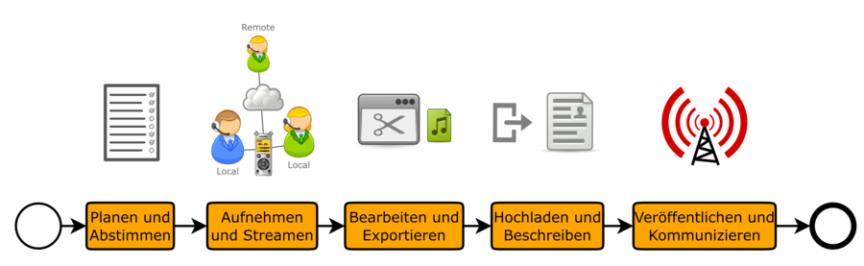

Typical podasting workflow

Not everything that is listed here necessarily has to be implemented in this way, but it is worth at least checking whether you can adapt one or the other to the requirements of a good recording from the outset without significant effort.

1. **Plan and vote:** The podcast workflow starts by planning and coordinating the date and content of each episode. A common appointment must be found and the recording situation (e.B. on site vs. remote) must be discussed. Key points are usually sufficient for content planning, as pre-formulated text often sounds unnatural and stiff (e.B. with Etherpad, Goodle Doc or OneNote).
2. **Recording and streaming:** This is followed by recording the raw material with software (e.B. Audacity, Reaper/Ultraschall or video conferencing tools) or hardware (e.B. zoom H6 audio recorder). Ideally, a multi-track recording is created, in which each podcast ending is recorded in its own track and can be edited. For remote participants, special tools (e.B. [Studio Link](https://studio-link.de), video conferencing tools), services (e.B. [Zencastr](https://zencastr.com)) or a so-called double-end recording necessary. If the audience should be able to listen live during the recording, a live stream will also be offered.
3. **Editing and exporting:** In post-production, the audio raw material is processed (e.B. shorten the front and back, cut out "ums" or passages, adjust levels). The finished cut is then exported in the desired audio format (usually [MP3](https://de.wikipedia.org/wiki/MP3) e.B. with 128kBit/s data rate, alternatively [M4a](https://de.wikipedia.org/wiki/MP4) or [Ogg](https://de.wikipedia.org/wiki/Ogg)).
4. **Upload and write:** The finished audio file is then uploaded to a Podhost and published. This can be your own website (e.B. Wordpress with [Podlove Podcast Publisher](https://podlove.org/podlove-podcast-publisher) or on the intranet SharePoint Online) or a special Podhost service (e.B. [Podigee](https://www.podigee.com)). Usually the podcast is supplemented by so-called show notes, a rough description of the content of the podcast. This allows potential listeners to quickly get an overview of the content. In addition, search engines can make podcasts easier to find through the shownotes.
5. **Publish and communicate:** If the audio file is uploaded to the Podhost and published, the aim is to communicate the episode to the target group. All podcast subscribers will receive the episode automatically. Via media such as newsletters, Twitter, social networks, e-mails, etc., new audiences can be won over to the podcast with each episode. For many podcasts, it is worthwhile to build a community for the exchange on the topics of the podcast (e.B. LinkedIn group, Slack network or Yammer community on the intranet).

## 2.4Hardware

The equipment used, as well as the location where a podcast episode is recorded, can vary greatly. From mobile recording with a smartphone to a fully equipped recording studio, all possibilities are conceivable. For each recording situation, the framework conditions that affect the quality of the recording must be taken into account in the planning.

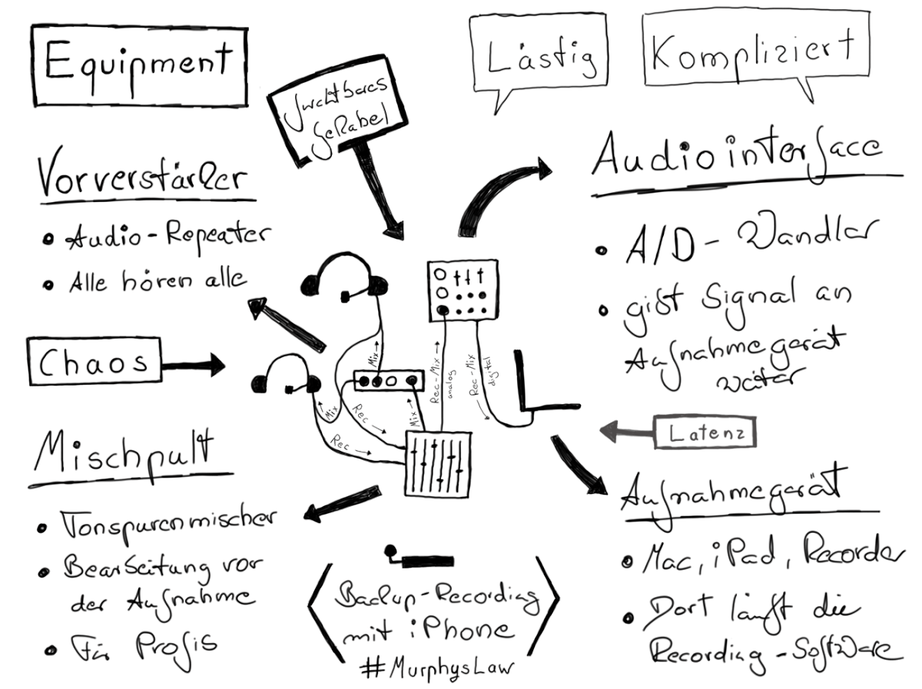

Original image: Marco Hitschler on zirkusliebe.de, CC BY, <https://www.unmus.de/podcast-in-a-nutshell/>

These hardware options are often used in podcasting setups and are described in the following capitles:

* **Microphones or headsets** (hearing-speaking combinations) for good sound quality
* **Audio recorder** to record on the go or in the meeting room
* **Audio interfaces and mixing consoles** to record good sound on the computer and are not dependent on built-in audio hardware (usually unusable)
* **Audio processing device** for effects such as compression, expansion and noise gate (previously often solved in hardware, meanwhile often in software)

**Tip:** attached to this guide is a list of materials with field-proven recommendations for podcasting hardware.

### 2.4.1Microphones and headsets

A recording is never better than its weakest link allows and, above all, a once lowered quality in the recording chain can no longer be upgraded (at best "saved"). Therefore, it is necessary to take care at the beginning of the recording chain not to make a significant mistake. The right choice of microphone is crucial, because everything stands and falls with the whirlwind of sound to an electrical signal.

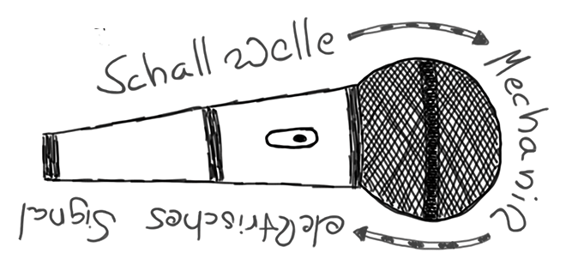

Original image: Marco Hitschler on zirkusliebe.de, CC BY, <https://www.unmus.de/podcast-in-a-nutshell/>

Two types of microphones can be distinguished:

* **Dynamic** microphones: A dynamic microphone generates the electrical signal by hitting a diaphragm, the movement of which is then transmitted to a coil. This coil encloses a magnet that generates a current flow in this coil by induction. This current is usually so small that a micronfamplifier must be used in addition to the microphone.
* **Condenser microphones:** Condenser microphones work according to the condenser principle: two metal plates closely opposite each other are charged with an electrical voltage and generate a magnetic field. Incident sound waves change the distance between the two plates and generate a corresponding current flow. Compared to the movement of the diaphragm/coil of the dynamic microphone, the sensitivity of a condenser microphone is significantly greater. To function, condenser microphones need a supply voltage, also called phantom voltage (e.B. 12V, 48V).

In addition, care must be taken to ensure that microphones have different recording characteristics. This means that they pick up sound waves coming from different directions at different sounds. Frequently used microphone characteristics are:

* **Sphere:** Sound waves from all directions (360 degrees) are recorded at the same loud.
* **Kidney:** the microphone has a preferred direction, from which sound waves are recorded particularly loudly, all other directions can only be heard attenuated (well e.B. in louder rooms).
* **Superniere:** like Niere, only that the directional function is even stronger.

Microphones are usually placed on a table as a table microphone or mounted on a tripod. A special design is the **headset** (e.B. Beyerdynamic DT297), in which microphone and headphones are guided together. Especially with inexperienced Sprecher_innen, this has the advantage that the microphone is always in the same place regardless of the head movement. Care must be taken to ensure that the microphone is not in the stream of breathing air (e.B four fingers away from the mouth and laterally at nose level).

**Tip:** the sound of a recording should never be heard in podcasts as in video conferences in the same room in which the microphone is located, otherwise feedback may occur. Therefore, a headphone or a headset should always be used.

**Tip:** the hands-free system of a mobile phone (e.B. iPhone) often offers surprisingly good sound quality (e.B. Earpod with jack or Lightning connection). However, you have to make sure that the microphone capsule built into the cable does not rub against clothes, scarf or hair.

### 2.4.2Audio recorders

An audio recorder is a device that can be used for audio recording without an additional computer. There are audio recorders with built-in microphones (similar to voice recorders), with connectors for external microphones (e.B.XLR jacks) or the combination of both. The devices usually record on SD cards and can be operated mobile with batteries.

Via USB ports, most audio recorders can be connected to a computer to transfer audio files or in use as an audio interface.

A very widely used audio recorder is the Zoom H6, which offers four XLR inputs, two channels for plug-in microphones or an audio-in (3.5mm jack). The Zoom H6 is based on SD card and can be operated via USB cable as an audio interface (unfortunately not both at the same time).

### 2.4.3Audio interfaces and mixing consoles

An [audio interface](https://de.wikipedia.org/wiki/Audio-Interface) can be used as an alternative to the audio recorder to record audio digitally directly in the computer. It forms the interface between audio sources such as .B instruments, microphones and the computer. The audio interface amplifies audio signals and converts the analog signals into digital ones. The connection to the computer is made e.B. via the USB interface (e.B. Behringer U-Phoria UMC204HD, Focusrite Scarlett 2i2).

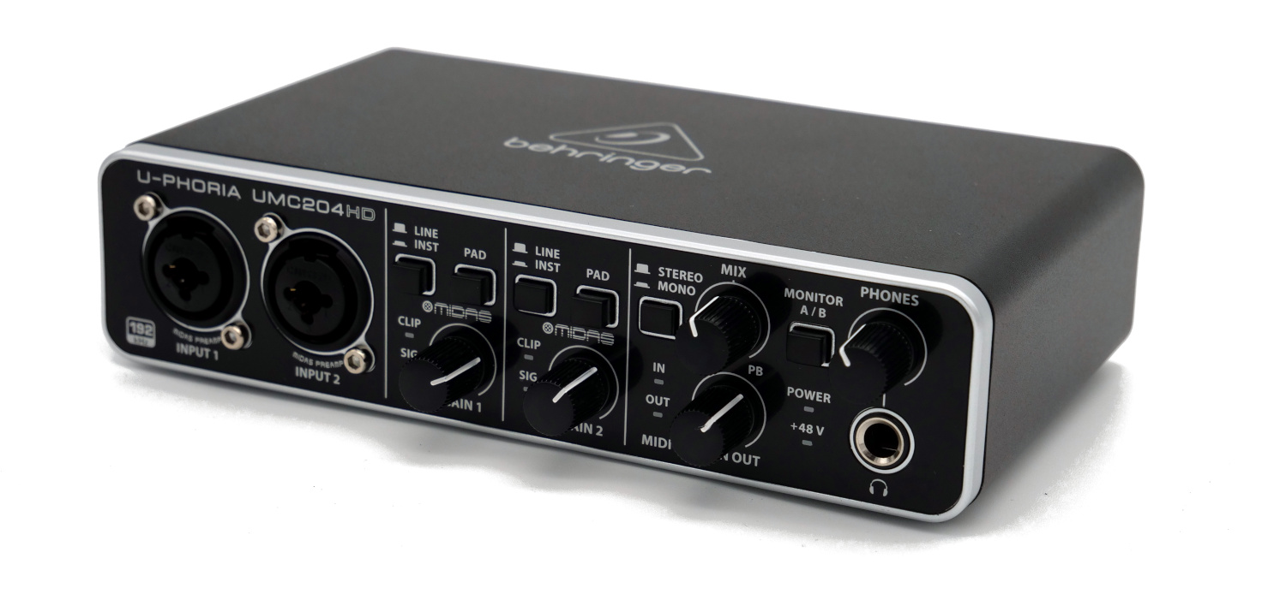

A [mixing console](https://de.wikipedia.org/wiki/Mischpult) is even more flexible than an audio interface. It usually offers a variety of input channels. The audio signal runs through the so-called channel strip, in the mixer from top to bottom). Each channel train represents the course of an input signal.

Some channel trains contain microphone inputs with preamplifiers, often with 48V phantom power. In the further course, the input signal can be influenced by equalizer in a sound image on each channel train and the distribution of the signal to the two stereo channels of the "Main Mix" can be adjusted (English "Panning"). A main control simply controls the volume of the input signal in the output of the mixing console (usually called Main Mix).

Mixing consoles can be purely analog (output is an analog signal) or can be used directly on a computer via an integrated audio interface (e.B. Yamaha AG series, Zoom L12).

Most mixing consoles are intended for the production of music. However, there are also mixing consoles that are specifically designed for podcasting needs (e.B. Rode Rodecaster Pro) and e.B. offer the following functions:

* Built-in soundboard for singles, jingles, bumpers etc.
* Built-in N-1 circuit for remote podcasting or to participate in video conferences
* Jack (TRRS) or Bluetooth connectivity, e.B. to connect smartphones
* Built-in headphone amplifiers
* Built-in effects such as noise gate, compressor and expander
* Function for setting Schnitt and chapter points

### 2.4.4Audio Processing

Audio processing (also known as audio effects) is the analog or digital manipulation of an audio signal. Typical audio effects are.

* **Compressors:** Compression is the most important signal processing in the radio sector. Everyone knows the effect of listening to the normal radio: whether you listen to "loud" music or a quietly talking news anchor, only rarely do you have to operate the volume control, because the same volume perception always sets in the core. This is an intended effect and is achieved by an elaborate compression.
* **Expander:** The expander is the little brother of the compressor and is especially helpful when recording with multiple microphones or when recording in conditions with annoying background noise. An expander is similar to a compressor, but quiet passages are made even quieter, while louder passages are changed less or not at all. The expander thus ensures that quiet sound sources that are not relevant for recording are automatically hidden during pauses in conversations. When recording with multiple microphones, the expander can restrict or prevent "crosstalk" from one microphone to another.
* **Noise Gate:** A noise gate mutes a microphone input when there is no audio signal. The threshold above which an audio signal is switched through can usually be set in the noisegate. A distinction is made between "hard" noise gates (microphone is switched on/off hard) and "soft" noise gates (microphone is softly adjusted up and down). Only soft noise gates are useful for podcasting.

**Note:** Audio processing can be implemented with effect devices in hardware or software. Digital audio processing usually has longer signal propagation times, which worsens the latency of the entire audio chain.

## 2.5Software

In the past, software was mainly used for editing podcasts, and hardware was recorded. Meanwhile, computers have become much faster and there is additional software available with which the production of podcasts without special audio hardware is possible.

Typical categories of software in podcasting are:

* **Digital Audio Workstation (DAW),** software for recording, editing and producing audio content (e.B Reaper).
* **Audio editor**, similar to the DAW, but much simpler and with fewer features (e.B. Audacity).
* **VoIP services**, software that is actually intended for telephony on the Internet (Voice over IP), but can also be used for remote podcasting (e.B. Studiolink).
* **Post-production services** that relieve podcasters of audio processing work such as e.B level adjustment, compression and noise suppression (e.B. Auphonic).
* **Virtual podcast studios** offer dial-up via web browser, functions for recording, chat and sometimes also video conferences. After the end of recording, the audio tracks can be downloaded.
* **Podcast Recorder apps**, with which you can record, edit and publish entire podcast episodes with your smartphone (e.B. Anchor).
* **Video conferencing tools** that can also be used to record remote podcasts (e.B. Zoom, MS Teams, Jitsi). However, attention must be paid to good audio quality and ideally also the function of multi-track recording.

### 2.5.1Ardour

[Ardour](https://ardour.org) is a software for recording, editing and mixing on Linux, macOS and Windows.

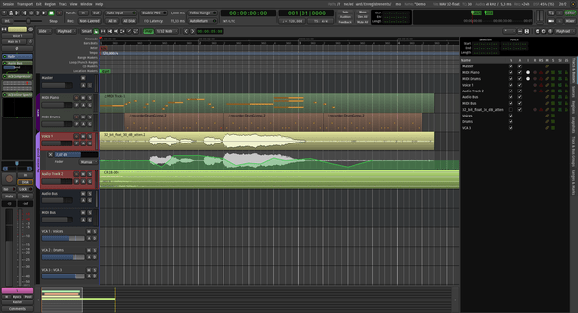

### 2.5.2Audacity

[Audacity](https://www.audacityteam.org) is a free and therefore free software solution for easy recording and audio editing. At its core, it offers everything you need to get started. The big disadvantage is that the editing function is destructive , i.e. once deleted areas in the audio track can no longer be restored. For large and complex projects, it is therefore more advisable to use a non-destructively cutting DAW (e.B. Reaper + Ultrasound).

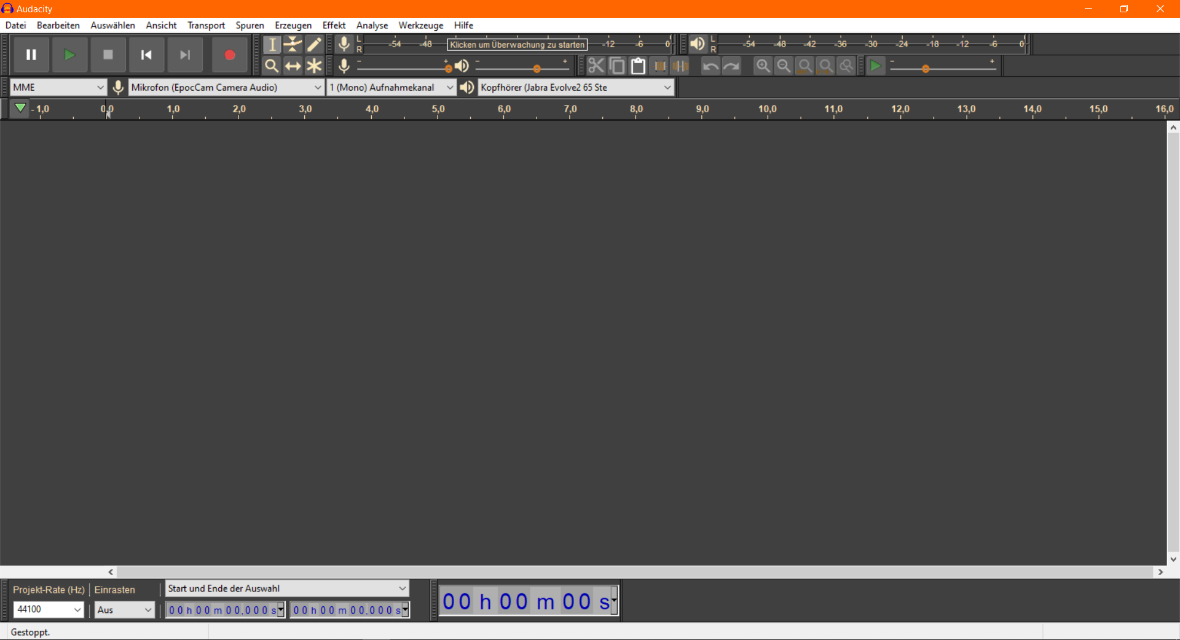

Screenshot Audacity

**Advantages:**

* Easy to learn for Einsteiger_innen
* Available for Windows, Mac and Linux
* Free (Open Source)
* Portable version available (no installation required)

**Disadvantages:**

* Destructive cut
* Little podcast functionality (e.B. Remote podcasting, livestream)

**Left:**

* [Documentation and FAQ](https://www.audacityteam.org/help/documentation)
* [Audacity](https://wiki.cogneon.de/Audacity) in COPEDIA
* [Audacity Portable](https://portableapps.com/de/apps/music_video/audacity_portable), version that can be used without installation rights

### 2.5.3Audition

[Audition](https://www.adobe.com/products/audition.html) is a "well-hung" piece of software from Adobe that shines with its performance and many possibilities to save broken recordings. Audition runs on Microsoft Windows, but now also appears on macOS.

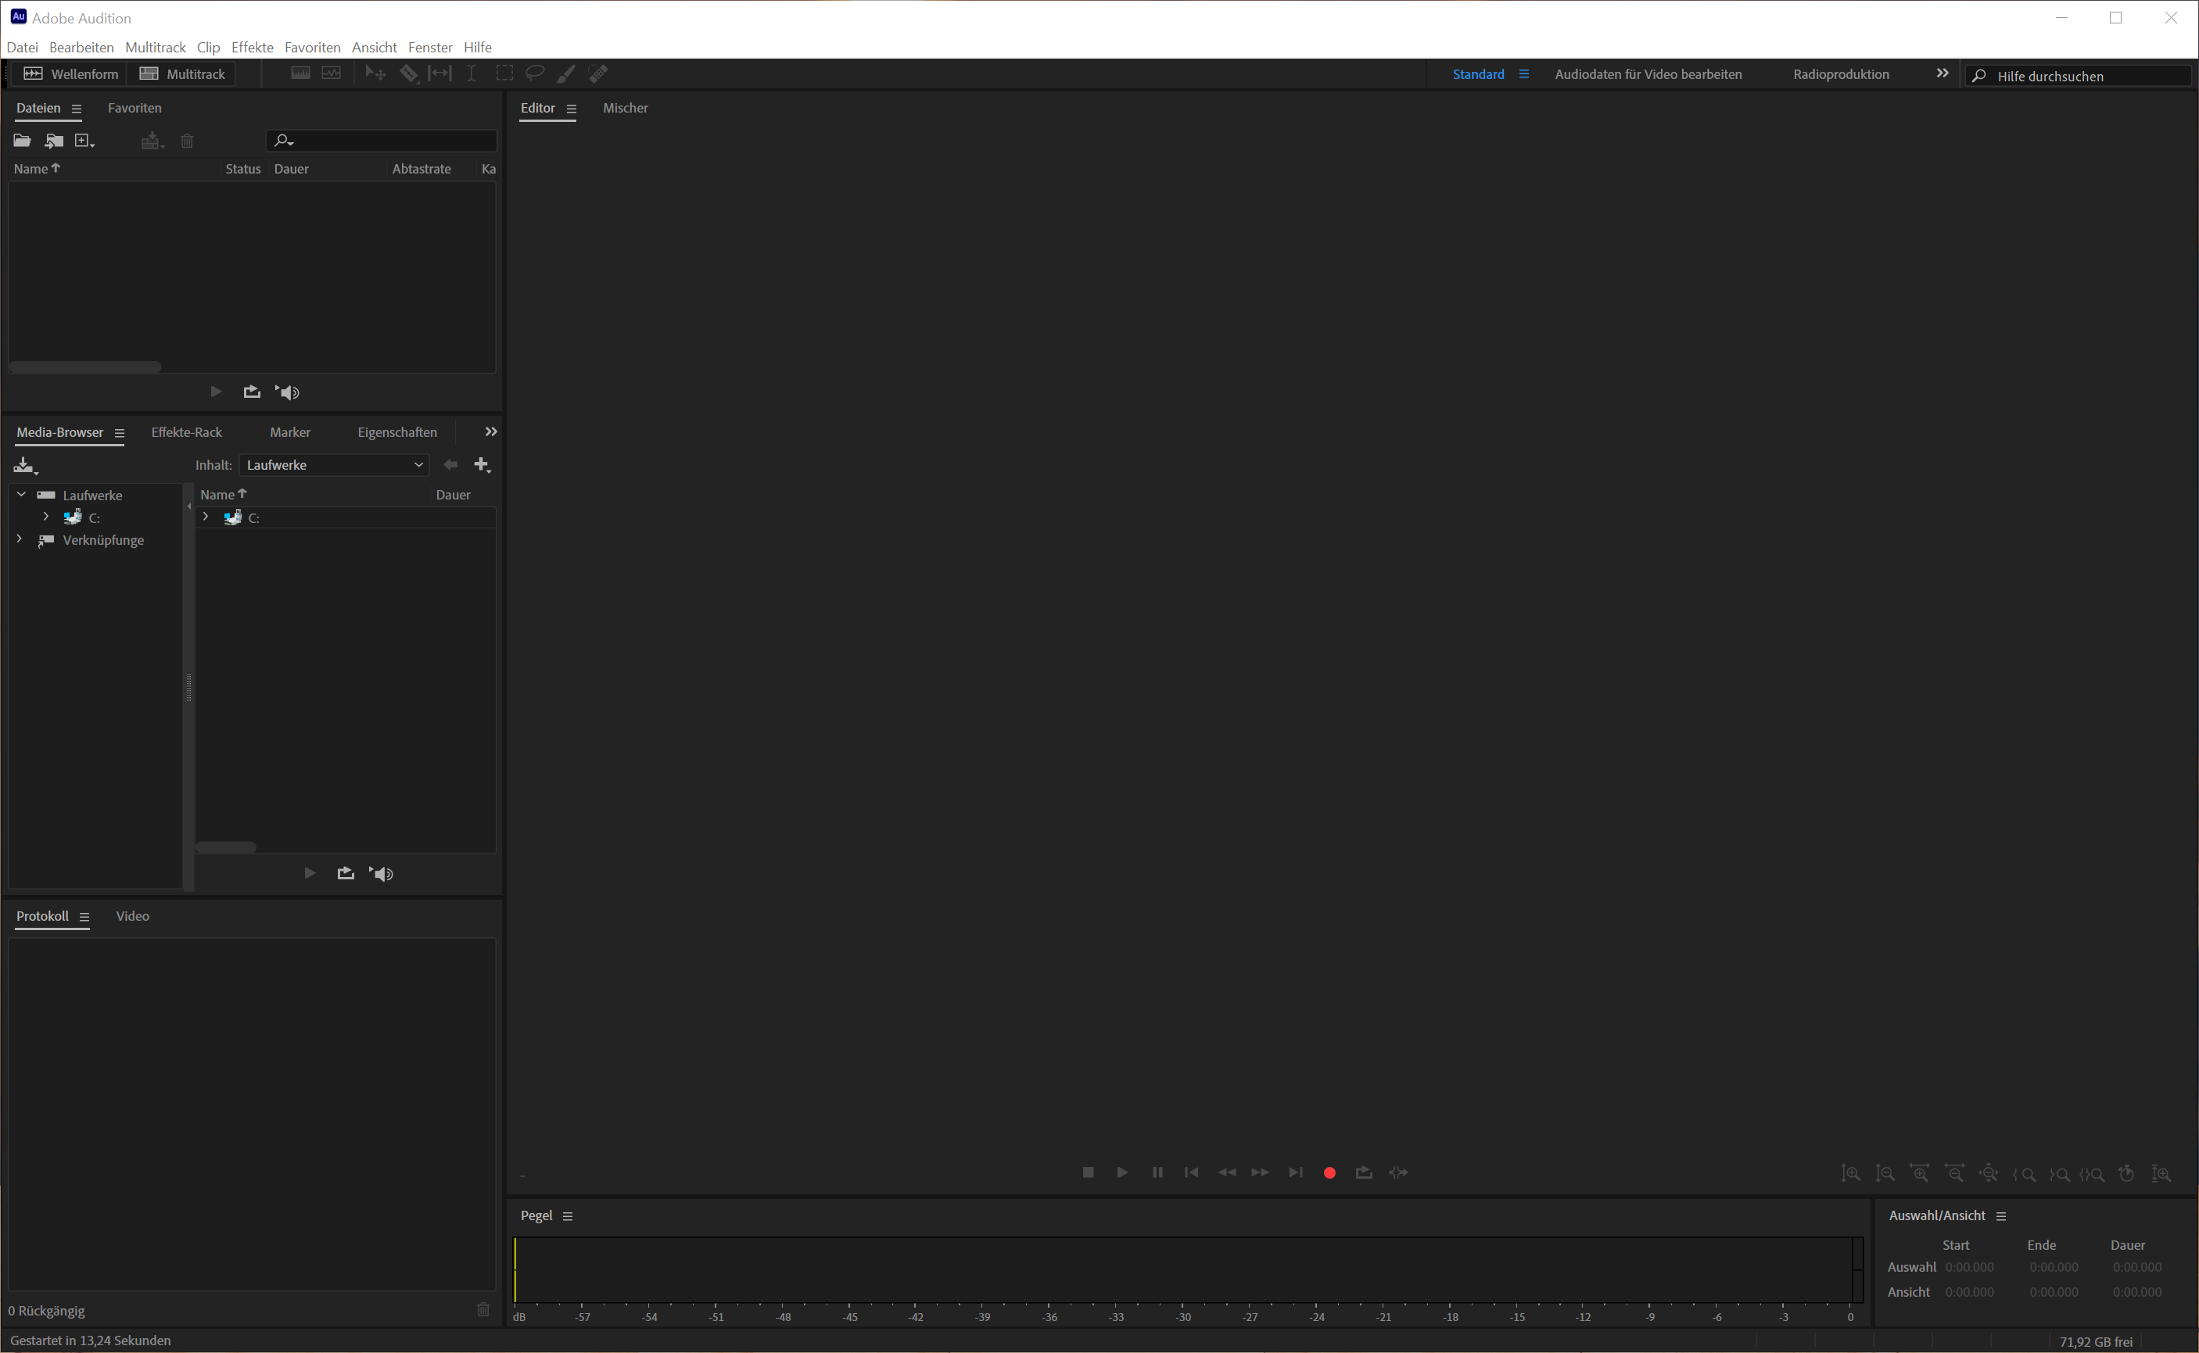

Screenshot

### 2.5.4Ferrite

[Ferrite](https://www.wooji-juice.com/products/ferrite) is an iOS app for recording and editing (multitrack) audio. Smaller audio projects can be recorded, edited and published on the iPad, e.B.

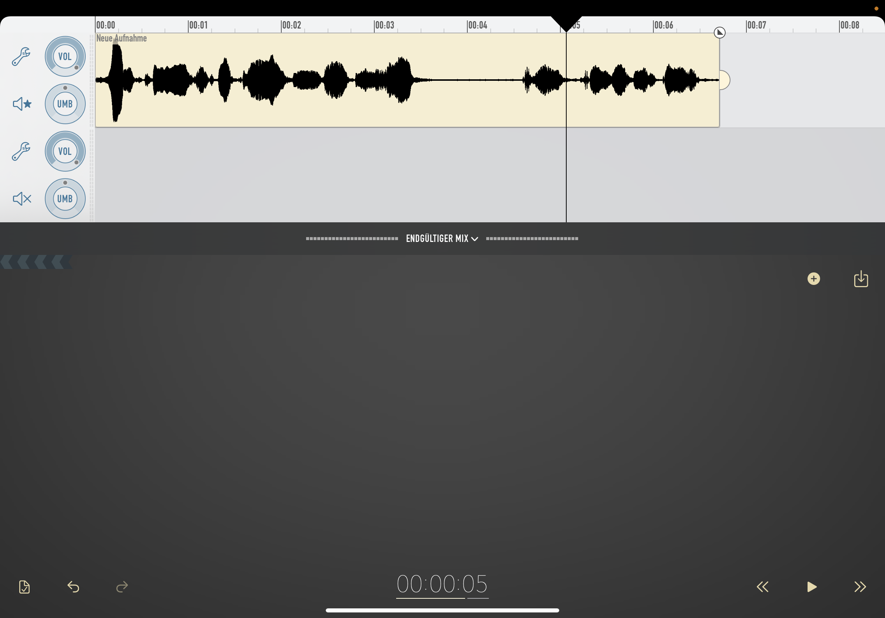

Screenshot Ferrites

**Advantages:**

* Complete production on a mobile device (e.B. tablet) possible
* Cost-effective (free basic version available)

**Disadvantages:**

* Complex audio projects are cumbersome to edit on mobile devices
* It is more difficult to operate audio hardware (e.B. audio interface) on mobile devices

### 2.5.5Garage tape

[Garageband](https://www.apple.com/mac/garageband) is a software from Apple for recording and editing music and podcasts. It is very easy to use and has many features that just support podcast recording and publication. So you can easily add chapter marks in Garageband. Garageband only runs on Mac OS X.

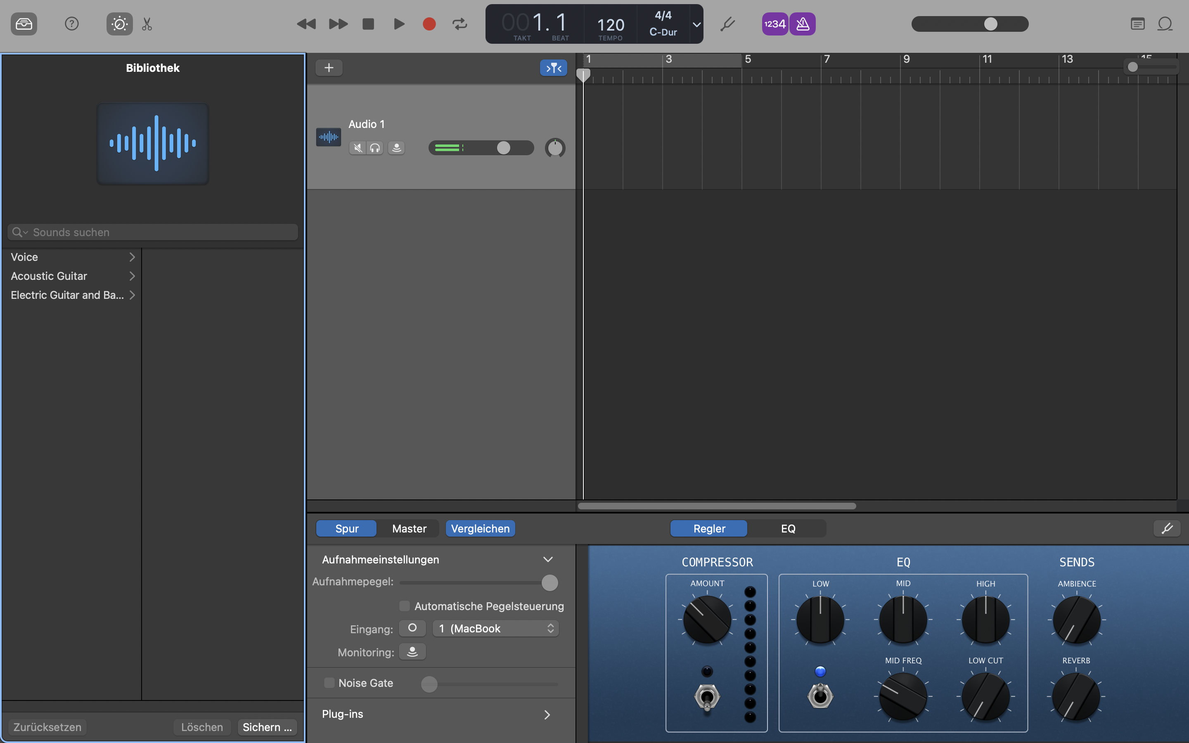

Screenshot Garageband

**Advantages:**

* Very easy to use
* Free

**Disadvantages:**

* Available for Mac and iPad only
* Few podcasting functions (e.B. remote podcasting, live streaming)

### 2.5.6Hindenburg

[Hindenburg](https://hindenburg.com) is a digital audio workstation for radio broadcasting and podcasts.

### 2.5.7Reaper + Ultrasound

[Reaper](https://www.reaper.fm) is an application for audio production with multi-track recording, midi recording and tools for editing, mixing and mastering music. The [Ultrasound](https://ultraschall.fm) project optimized Reaper for recording and producing podcasts.

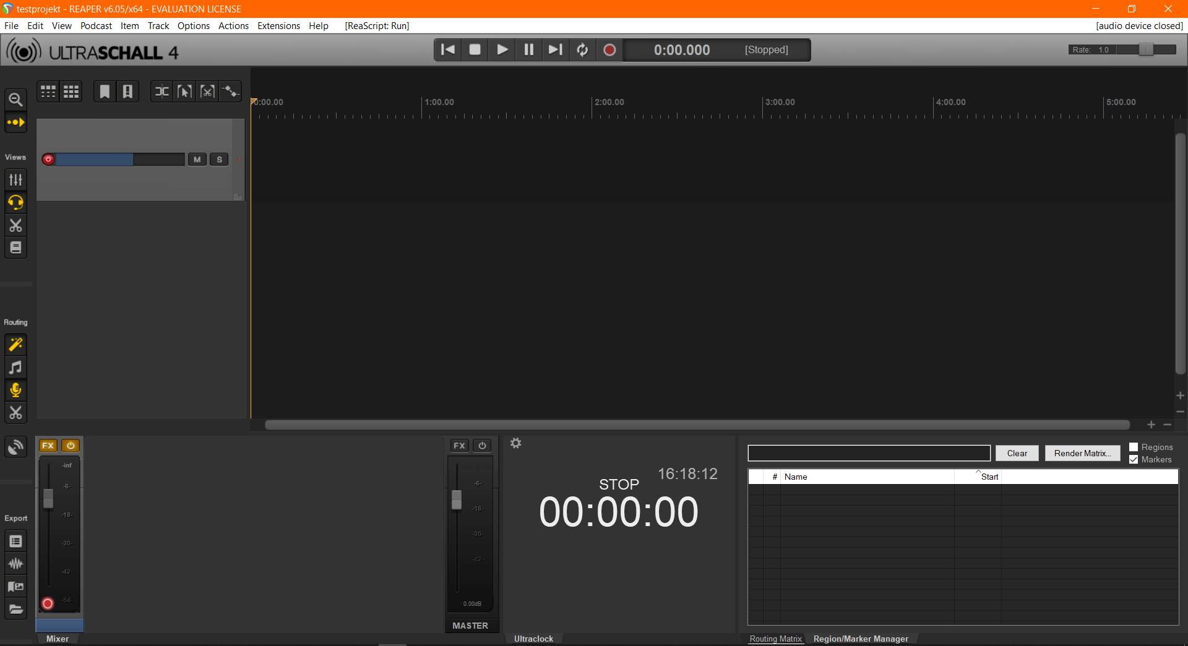

Screenshot Reaper + Ultrasound

**Advantages:**

* Reaper is cheap, ultrasound for free
* Very complete range of functions for podcasting (e.B. remote podcasting, live streaming, levelling)
* Available for Windows and Mac

**Disadvantages:**

* Complex installation process
* Compared to software such as Audacity, higher training effort

**Left:**

* [Ultrasound Tutorial](https://docs.leonidlezner.de/ultraschall-tutorial) by Leonid Lezner
* c't Article [From Zero on Shipment](https://www.heise.de/select/ct/2020/14/2014915163287581935) (Ultrasound 4)

### 2.5.8Studio Link Standalone

[Studio Link](https://studio-link.de) enables high-quality audio connections over the Internet, e.B. for quick and easy integration of guests. By using the Opus audio format , connections with Studio Link are usually of high quality and low latency.

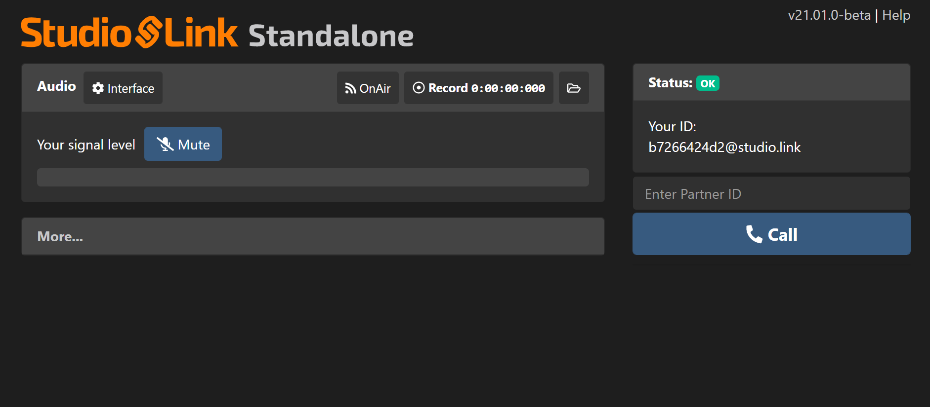

Screenshot Studio Link Standalone

**Advantages:**

* Easy way to record remote podcasts
* Free
* Available for Windows, Mac and Linux
* Local recording possible (good with poor Internet connection)

**Disadvantages:**

* No influence on recording parameters (Note: Since version v21.07.0 the volume can be adjusted. However, this should only be used if there is no other option for local gain customization.)

### 2.5.9Zencastr

[Zencastr](https://zencastr.com/) is a podcast recording software that runs entirely in the browser (no installation required). There is a free and a paid version. In addition to audio tracks, a transmission of video (e.B. webcam is also possible).

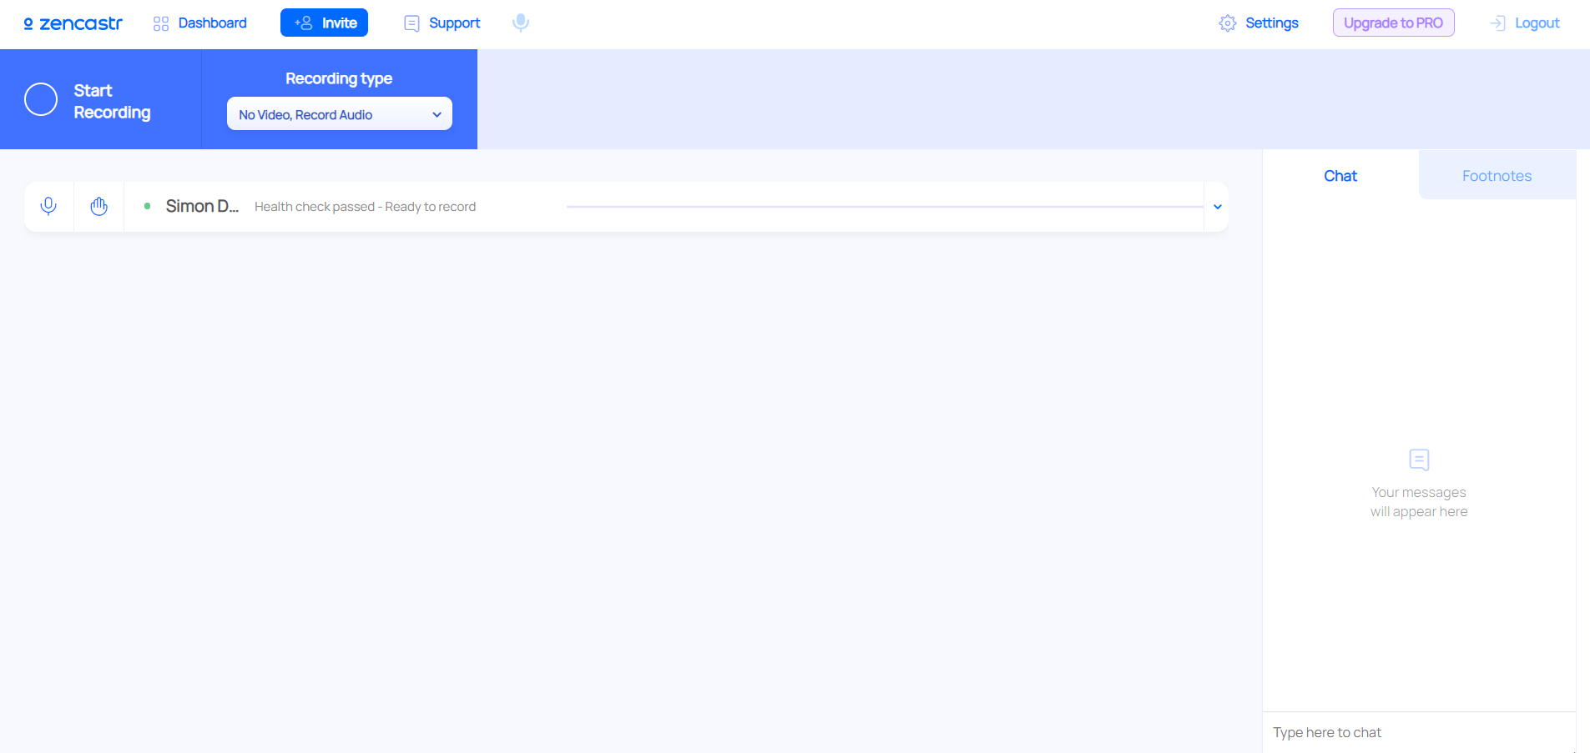

Screenshot Zencastr

**Advantages:**

* Completely web-based, no installation of software necessary
* Easy to use

**Disadvantages:**

* Few configuration options

## 2.6Studio

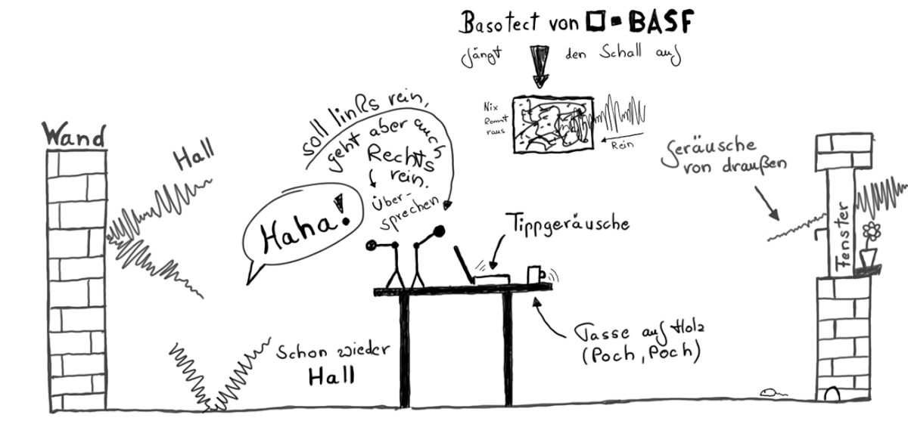

Original image: Marco Hitschler on zirkusliebe.de, CC BY, <https://www.unmus.de/podcast-in-a-nutshell/>

### 2.6.1Room situation and reverb

If you record within a room, you should look for a room that does not develop so much reverb. Kahle walls and, above all, smooth window fronts are the main cause of Reverb, who afterwards lies down disturbingly on the recording and makes it unnecessarily difficult for the listeners to follow the conversation.

It is not always easy to prevent existing reverb, so one should immediately look for a room that brings with it a certain "disorder": sloping walls, bookshelves, plants, upholstered furniture and carpets, tapestries and curtains – all this contributes significantly to not providing too much reflective surface for sound and absorbing or diffusing it.

If you want to set up a fixed room as a recording studio, you should consider whether to surround critical points or even install absorbent materials. A large window front can be quickly controlled by a Molton curtain. Tapestries can defuse walls.

For this purpose, it makes sense not to bring too many additional "sound bodies" into play. Metal or glass tables can be uncomfortable when participants drive around on the surface with their hands or any office supplies. Here a solid wooden table makes more sense, if necessary you can also create relaxation with desk pads.

### 2.6.2.Speaker position

A comfortable sitting position is very advantageous for voice recordings. Ideally, however, you should not sit curved together in the sofa, but as upright as possible, so that the chest and abdominal area can develop its full breathing support.

Wer mag can also stand the same or at least use a standing aid or high seat. Then speaking is the easiest, you can speak loudly and directly more easily and will be better understood in the end.

### 2.6.3Microphone

The task of the microphone is to optimally capture the speech of each conversation participant and to convert it for recording. Therefore, it is optimal if each participant also has his own microphone.

Although you can also record several people with a community microphone, it will hardly be possible to avoid that you always take up a lot of "space", which has a disturbing effect on the recording. The effort to assign each participant his own microphone is therefore worthwhile in any case. If you want to save money here, you should be aware of your options when choosing the right microphone.

Accordingly, you also need your own microphone input (microphone amplifier) on the mixing console or recording device for recording. So the right capacity must be available here.

## 2.7Literature and Links

**Literature:**

* Diemand, V., Mangold, M., Weibel, P.: [Weblogs, Podcasting and Videojournalism: New Media between Democratic and Economic Potential](https://amzn.to/2TUDJsk). Heise Zeitschriften Verlag GmbH 2006.
* Hagedorn, B.: [Podcasting: Konzept, Produktion, Vermarktung](https://amzn.to/2OkCbSg). mitp. 2016.
* Herrington, J.D.: [Podcasting Hacks. Tips & Tools for Blogging Out Loud](https://amzn.to/2U6KtCK). O'Reilly Media. 2005.
* Pieper, F.: [The P.A. Handbook Practical Introduction to](https://amzn.to/2OkU3wt) [Professional Public Address Technology](https://amzn.to/2OkU3wt). GC Carstensen Verlag. 2011.
* Rokk, K.: [Die Podcasting-Goldgrube. The comprehensive guide for podcast beginners](https://amzn.to/2U83vbK). CreateSpace Independent Publishing Platform. 2014.
* Rubens, A.: Podcasting. [The book on audio blogging](https://amzn.to/2UN5VJY). O'Reilly Verlag GmbH. 2006.

**Links:**

* Wikipedia Article [Podcast](https://de.wikipedia.org/wiki/Podcast)
* [Apple Podcast FAQ](https://www.apple.com/de/itunes/podcasts/fanfaq.html) - What is a podcast? How do I get into podcasts on iOS?
* [Sketchnote Podcast in a Nutshell](https://www.unmus.de/podcast-in-a-nutshell) - A little guide to orientation in the complicated world of podcasting
* [fyyd.de](https://fyyd.de) - Podcast Search Engine
* [Das Sendezentrum](https://das-sendezentrum.de) - Der Schmelztigel für die freie Podcast-Szene, u.a. Podcast Konferenz [SUBSCRIBE](https://das-sendezentrum.de/subscribe)
* [sendegate.de](https://sendegate.de) - The Podcasting Community
* [The Speaker](https://der-lautsprecher.de) - A podcast about sending and receiving
* [International Podcast Day](https://internationalpodcastday.com) - Every year on September 30, well suited to raise awareness of podcasts and win new Hörer_innen/Podcaster_innen
* Article [How the podcast market is developing](https://blog.medientage.de/so-entwickelt-sich-der-podcast-markt) (2020)
* Article [Podcasts – come to stay The audio trend at a glance](https://bvdw.org/fileadmin/user_upload/BVDW_Podcast-Audio_Trend_2020_im_UEberblick.pdf) (BVDW, 2020)

# 3Podcasting Learning Path

The Podcasting Learning Path is for learners who want to start their own podcast on the Internet or intranet. The learning path consists of 11 katas (exercises), with which you learn to find and listen to podcasts and finally to produce them yourself. It is recommended to go through the path with 4-5 people in a 12-week sprint so that you can help each other.

**The learning path at a glance:**

| No. | Kata |
| --- | --- |
| 1 | Get Started |
| 2 | Choose a podcast app and find podcasts |
| 3 | Use the Podcast Canvas as a checklist |
| 4 | Record your "zero number" |
| 5 | Your Podcast Studio |
| 6 | Attention Recording Episode 1 |
| 7 | Your podcast website |
| 8 | Attention Recording Episode 2 |
| 9 | Publish your episodes |
| 10 | Communication, Communication, Communication |
| 11 | Podcast Clinic |

## 3.1Get Started (Kata)

**Step 1: Learn the basics of podcasting**

Use the Basics chapter to familiarize yourself with the basics. Use the Literature and Links chapter to provide you with additional necessary material.

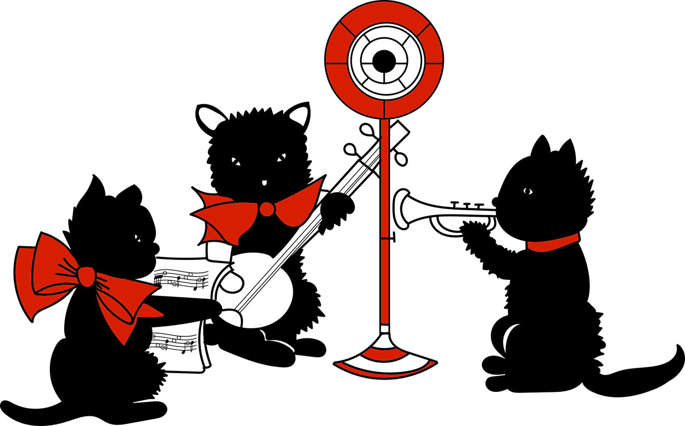

To start your own podcast, you need some background on:

* Basic audio terms (microphone technology, engraver types, codex, software types, etc.)
* The five steps of the podcasting workflow
* The many possibilities of podast formats
* Necessary hardware and software
* The location of recording from mobile scenarios to meeting rooms to the studio

## 3.2Choose a podcast app and find podcasts (Kata)

**Step 1: Choose a podcast app**

Check your smartphone to see if a podcast app (including Podcatcher) already exists. If not, go to your operating system's App Store and install the Podcast app of your choice.

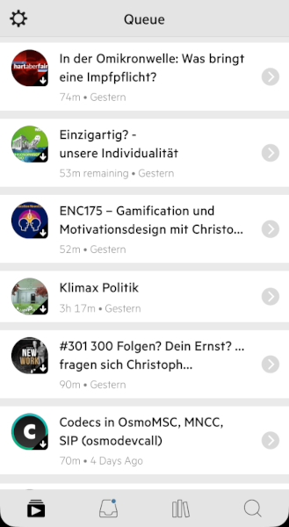

Podcast episodes at Podcatcher Castro

Frequently used podcatchers are:

* Antenna Pod (Android)
* Castro (iOS)
* Downcast (iOS, Mac)
* Pocket Casts (Android, iOS)
* Podcasts (iOS)
* Podcat (iOS)

**Step 2: Listen to podcasts and look for role models for your podcast**

Search your podcast app, search engines, or other platforms for podcasts that are relevant to your goals, areas of knowledge, tasks, and project. Subscribe to at least five podcasts and listen to them in your everyday life. Look for examples you'd like for your own podcast.

## 3.3Use the Podcast Canvas as a checklist (Kata)

**Step 1: Think about how you want to work with Podcast Canvas**

The Podcast Canvas is available as a graphic in PNG and SVG format. You can print out the canvas and work on it, e.B. with small sticky notes.



If you want to work electronically with the Podcasting Canvas, you can choose e.B. the following approaches:

* Copy the canvas into your Memex/digital notebook and label it there (e.B. Microsoft OneNote)
* Copy the canvas into a whiteboard tool and work there with digital sticky notes (e.B. Conceptboard, Miro, Mural, Microsoft Whiteboard)
* Copy the canvas into an (online) drawing program and use graphic and text elements for caption (e.B. draw.io)

These are just a few examples of how you can use the canvas, but there should be no limits to your creativity here.

**Step 2: Start filling out the Podcast Canvas for your podcast**

Use the Podcast Canvas to think about all the design dimensions of your own podcast based on the key questions. The guiding questions give an order that you should follow first.

To formulate and write down initial ideas for all fields. Identify the biggest open questions for you. Over the next few weeks, you can use the canvas to further refine your podcast concept and answer the open questions after and after.

**Tip:** If you already know which hardware and software you still need, take care of procurement at an early stage (ordering processes and delivery routes can take time).

## 3.4Take up your "zero number"

**Step 1: Slim equipment for the zero number**

So that you do not postpone the entry into recording audio (keyword: procrastination), you now take a first (short) episode to familiarize yourself with the technique and the sound of your assets in the podcast.

If you don't have the equipment you want to use later, that's no problem either. You can also record the first version of the zero number with your computer's microphone, existing microphones, or the smartphone.

**Tip:** [Making good sound recording with the iPhone](https://leonidlezner.de/gute-tonaufnahme-mit-dem-iphone-machen/) describes how to achieve good audio quality even with a smartphone (is used on the basis of an iPhone, but the instructions can also be used for other smartphones).

**Step 2: Record the zero number**

Many podcasts use a zero number (the issue before episode 1) to introduce themselves and their podcast to the target audience and create the right expectations. A zero number usually takes only a few minutes.

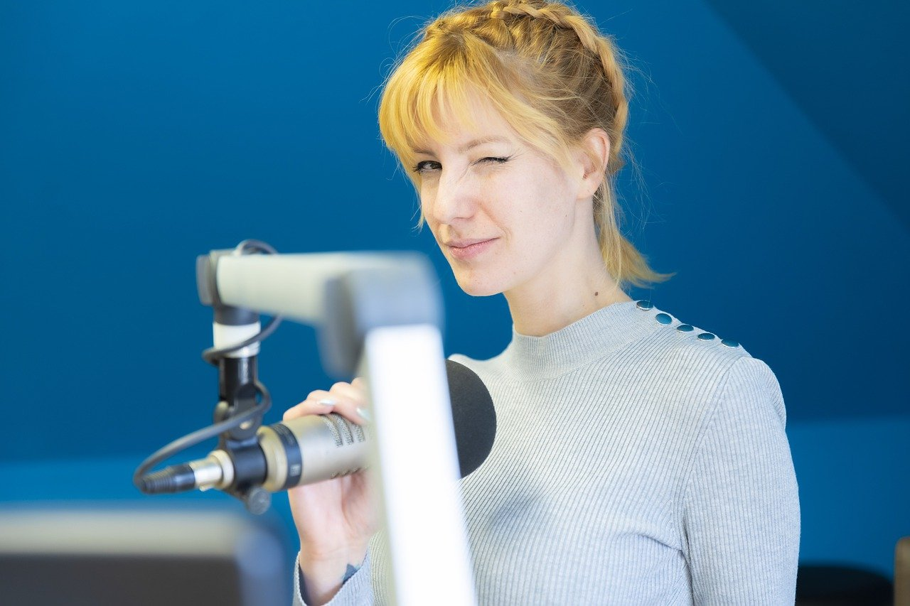

Typical questions answered in a null number are:

* Why am I doing the podcast?
* Who is the podcast for?
* How long is an episode?
* How often do episodes appear?
* Which topics are covered?

Now take a first version of the zero number for your podcast on cut start and end. In the null number, cover the topics from your podcast canvas. Let others listen to your zero number and get feedback with which you can improve your podcast concept.

**Tip:** [on fyyd.de, there is a curation of zero numbers](https://fyyd.de/user/hoersuppe/curation/nullnummern?page=0) that you can use to listen to examples of zero numbers from other podcasts and get ideas.

## 3.5Di Podcast Studio (Kata)

**Step 1: Choose your podcast studio(s)**

You probably don't have a room that's just used as a podcast studio. Nevertheless, you should spend some time on making the space and environment you use for recordings as optimal as possible. Maybe you also have several places where you would like to record (e.B. at home, in the home office, in the office, in discussion rooms, on the road e.B. at events or conferences)?

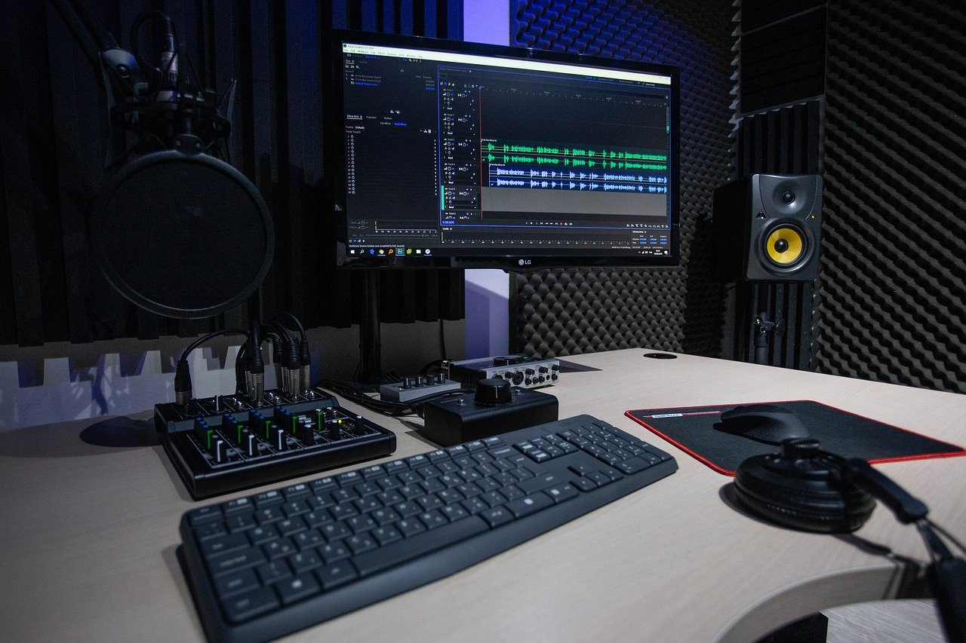

Depending on the recording location, you should consider what you have to consider for the best possible recording, e.B.

* Positions of podcasters
* Avoidance of room reverberation (e.B. insulation, avoidance of smooth surfaces)
* Noise
* Standard Setup Hardware
* Standard Setup Software
* Cabling
* For mobile use: transport containers to avoid damage and loss

**Step 2: Try Podasting Equipment**

Use some time to familiarize yourself with hardware and software. Over the course of your podcast career, your experience will continuously improve your studio.

**Tip:** if you're doing remote podcasts with people who don't have good audio equipment, it's worth having a small podcasting set to send (e.B. Focusrite Scarlett Solo + Beyerdynamic DT 297).

## 3.6Attention Recording Episode 1 (Kata)

**Step 1: Plan your first episode**

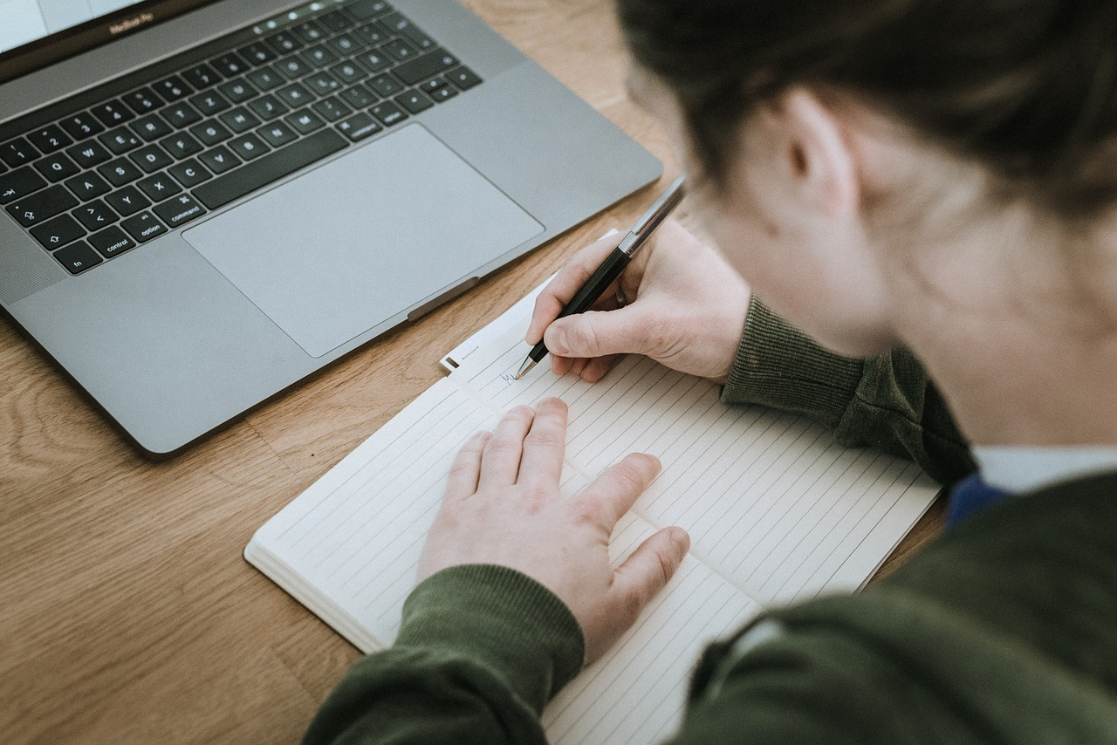

You have already thought about the rough structure of your podcast episodes in the Podcasting Canvas. Now it's time for the detailed planning of the first episode:

1. Are you alone or do you have other people on the podcast?
2. Do you record on site or are people remote? (Do a technical check!)
3. What topics are covered in the podcast? What questions do you want to ask? Create at least one "red thread" with bullet points on the themes of the episode.
4. What do you need to research for the episode? What background information do you still need?
5. Where do you document episode planning? To keep the effort low, you can document the red thread so that you can use it for the show notes.

**Tip:** on the Internet you can use e.B. Google Docs or Etherpads to schedule episodes. In the Intranet, this is possible e.B. with OneNote, Word, Wikis or the Wiki function in Microsoft Teams.

**Step 2: Record the first episode**

Create the recording of the episode now. Take as many shots as you take until you're happy with the result. If you have promised yourself , just take a short break and put it on again. When editing audio, such editing is much easier than with video. There are a few things you should keep in mind when recording:

* Are your devices well supplied with Stom (use battery only when absolutely necessary)?
* Do you have the level of the recording in view so that the recording is not over- or underdriven.
* Have you done everything you can to avoid noise (door closed, phone off, window closed, etc.)?
* For remote recording: is the network connection stable (better to use LAN than WLAN)?
* Do you have a backup recording for security in case something doesn't work out with the actual recording?

**Step 3: Edit and export your first episode**

The recording is in the box, now it goes to the Schnitt. For this, it is important to find the right "cutting strategy" for you:

* Start from the back: how much time do you want to invest in the cut?
* Do you want to cut out all uh's?
* Do you want to insert music, separators, bumpers, intro, outro etc.?
* Do you want to use effects like compression, expansion in post-production?
* Do you want to provide shownotes for your episodes?
* Do you want to provide a transcript of your episodes?
* Do you want to use chapter points to navigate your podast?
* Want to use chapter images?

When the recording is cut, export the final audio file of your episode (in many tools this is also called "render"). Recommended to start is to create an MP3 file with 128kBit/s (bitrate) in stereo. If you have the time and desire, try different bit rates and find the right quality standard for you.

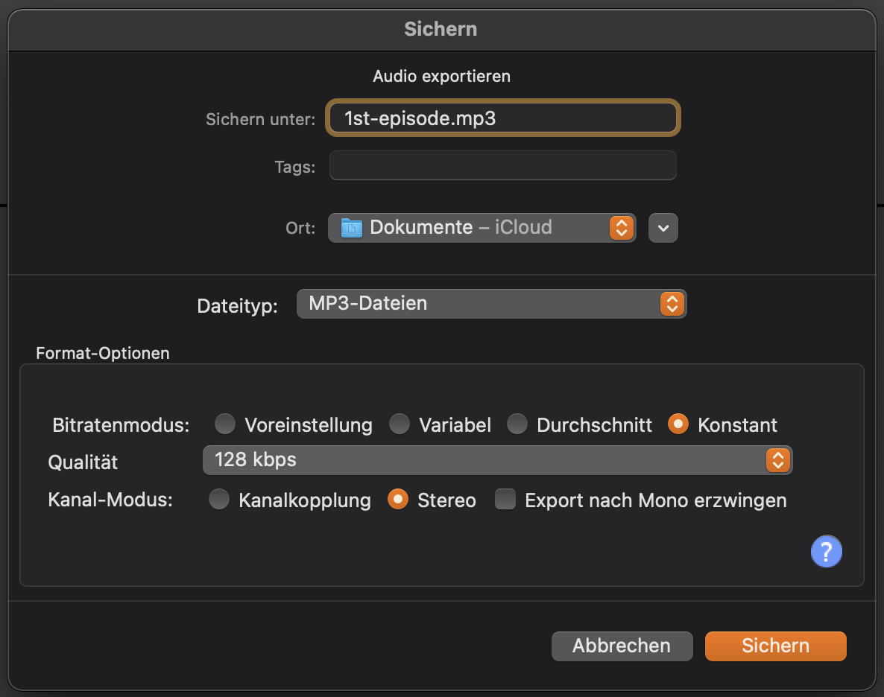

Export Dialog in Audacity

When the first episode is finished, let others listen to it and get feedback. For this you do not need a website yet, e.B. just send a link to the file in a file sharing service (e.B. Drobpox, OneDrive).

## 3.7Your podcast website (Kata)

**Step 1: Get inspiration for your Podcast website** Most podcasts have as their "home" a website on the Internet or intranet that serves as a contact point for new Hörer_innen. Your regular Hörer_innen will have subscribed to the podcast and usually listen to it in the Podcatcher on your smartphone , but especially for new Hörer_innen the website is important. First, look at websites from your favorite podcasts and think about what content you want to have on your website. An example (Forschergeist Podcast):

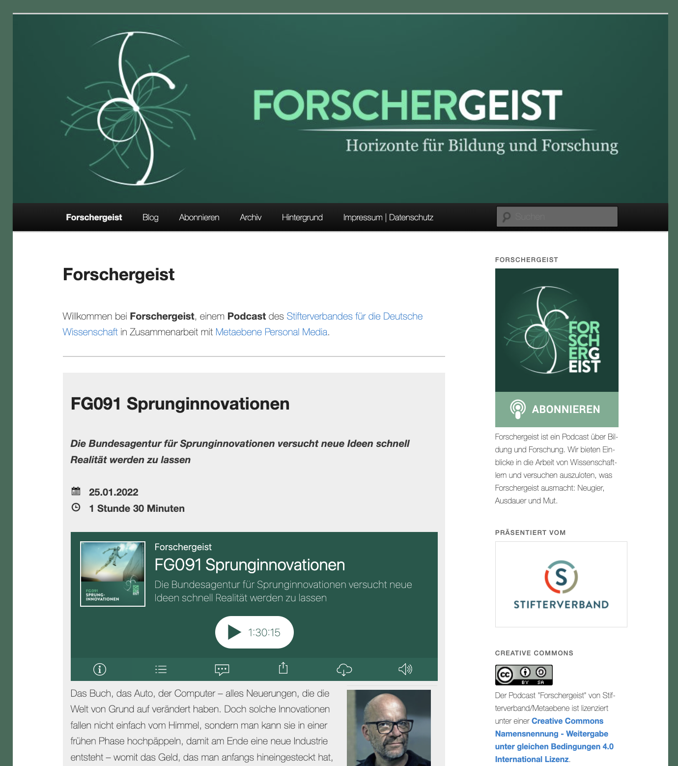

Screenshot of the website of the Forschergeist Podcasts (forschergeist.de)

Typical elements of a podcast website are:

* Header with logo of the podcast (usually similar to cover art)
* Short description of the podcast
* Highlighting the current episode and/or particularly good episodes
* Archive of all episodes
* Possibility to subscribe to the podcast (e.B. subscribe button, RSS logo) and usually also a description (especially if the target group is not used to dealing with podcasts)
* Possibilities of supporting the podcast (e.B. helping with research, suggesting guests, financial support)
* Information on license (e.B. open Creative Commons license) and legal framework conditions (e.B. imprint, data protection)
* Link to a community platform for Hörer_innen of the podcast
* and what information should be contained on it (e.B. logo, short description, current episodes and archive, instructions for subscribing, link to the community and social media, license, imprint & legal).

**Step 2: Create the first prototype of your podcast website**

Think about where you want to build the website for your podcast. Ideally, you create the prototype in the right software, but if necessary, paper and pencil are also sufficient. If you use software, familiarize yourself with it.

**Tip:** Talk to other Podcaster_innen who use the same software. They can usually tell you many tips and best practices.

Typical platforms for podcast websites on the Internet:

* Wordpress e.B. with [Podlove](https://podlove.org) Podcast Publisher
* Podigee
* Anchor
* Libyan
* Spotify (actually audio-on-demand and not a podcast because there is no feed)

Typical platforms for podcast websites on the intranet:

* SharePoint Communication Site
* Vimp
* Kaltura
* Yammer or Microsoft Teams for the community

Show others the prototype of your podcast website and get feedback.

**Step 3: Publish your first episode**

Publish your first podcast episode on your Podcast website now. Typical steps for this are:

1. Upload podcast episode (this can be directly on the website, or with a separate pod hosting service such as .B. Podigee, podcaster.de)
2. Create a contribution to the episode with title, text (shownotes, links, infos to participants), keywords (categories, hashtags) and audio player (in Wordpress these are e.B posts, in SharePoint news)
3. Publish podcast episode, done :-)

## 3.8Attention Recording Episode 2 (Kata)

**Step 1: Reflect on the experiences from Episode 1**

Run an [after action review of](https://de.wikipedia.org/wiki/After_Action_Review) your first episode with the following questions:

1. What did you expect from your first episode?
2. What actually happened?
3. What went well and why?
4. What can be improved and how?

Write down the feedback you received about your first episode. What can you learn from this? What can you do better in Episode 2?

**Step 2: Produce episode 2**

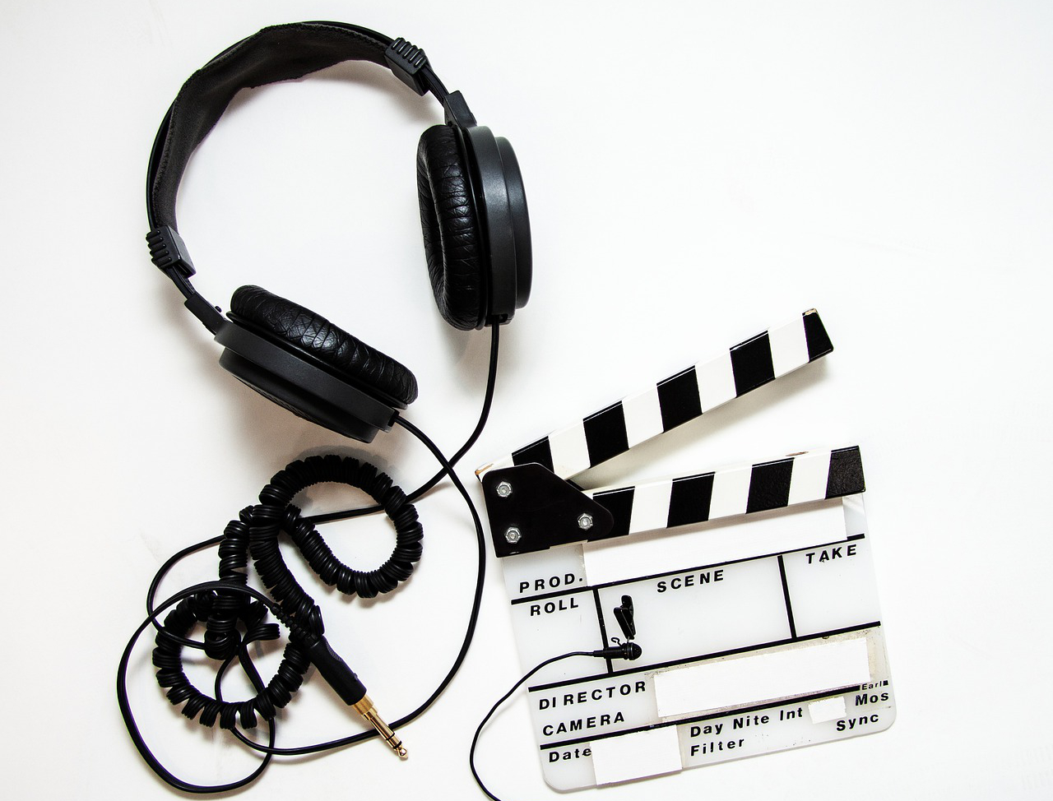

Record the second episode of your podcast and do the post-production. Take into account all findings from step 1. Result is your third audio file after zero number and first episode. Take all the steps of post-production (shownotes etc.) as defined in the canvas and when creating Episode 1. If your skills and recording quality have improved a lot so far, you can consider re-recording the zero number and/or the first episode.

## 3.9Publize your episodes (Kata)

**Step 1: Publish your episodes**

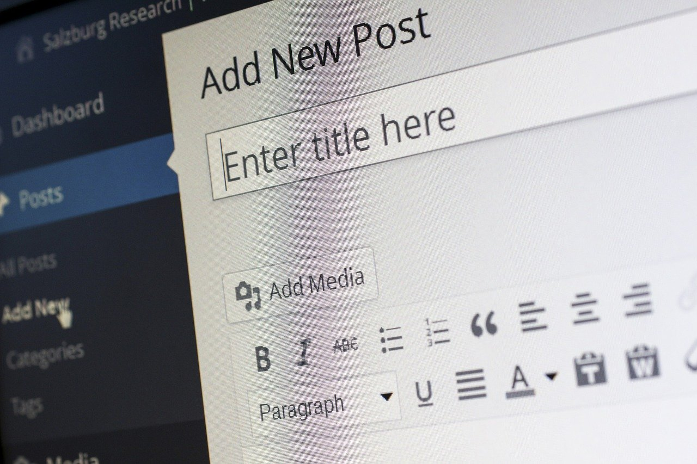

Publish your null number and the first podcast episode on your podcast website. Decide whether you want to release the second episode right away, or later, to have a further episode "in the camp".

**Step 2: Test all episodes**

The best recipe against errors is "test, test, test!". Run the following tests on your podcast episodes (omit not applicable):

1. Can the episodes be played and downloaded on the web?
2. Do the social functions (like, share, comment, etc.) work?
3. Can your podcast be found in the podcast directories/search engines?
4. Can the episodes be played in podcatchers?
5. Do the additional functions work in the podcatcher (show notes, chapter marks, chapter images, etc.)

## 3.10Communication, Communication, Communication (Kata)

**Step 1: Promote your podcast**

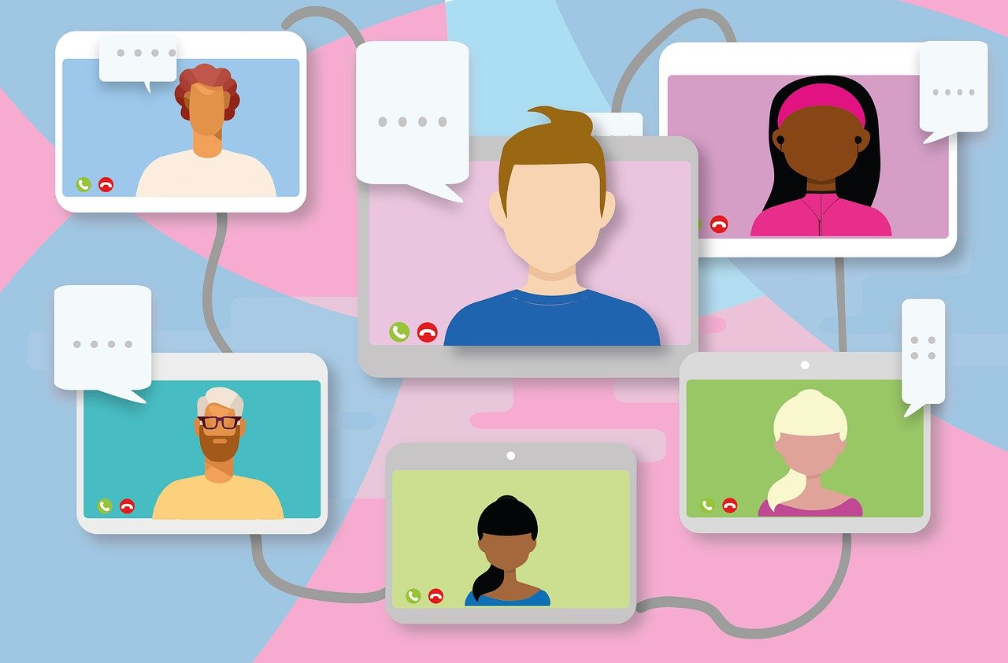

Make your podcast known through the channels you choose in the Podcasting Canvas and encourage discussion and feedback. Reserve some time to respond to feedback and questions. Collect all feedback to continuously improve your podcast in the future according to your goals and the wishes of the target group.

A good way of communication is word-of-mouth. Ask your podcast guests to make the podcast known on their networks. Create small text modules and/or graphics that can be easily shared/forwarded. Think about which people could be multipliers/influencers for your podcast and ask them to be redirected.

**Step 2: Trade fair for success**

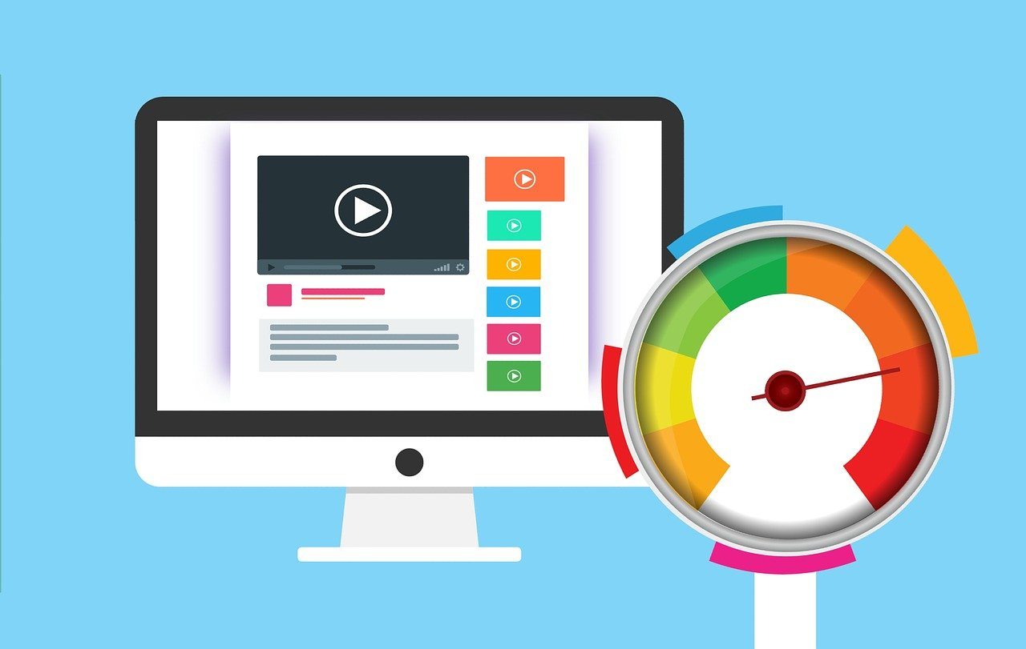

You have to decide for yourself how important hard numbers are to you for your podcast. If you're making money from your podcast through advertising, numbers are probably more important than if you're producing an in-house knowledge podcast.

The correct measurement of podcasts is not so easy. Some listen to your podcast through an app, others through the website. A downloaded episode is not yet a listened to episode. Think about which metrics for your podcast best reflect your goals. If you want to deal with valid measurement, check out the [iab Podcast Measurement Technical Guidelines](https://iabtechlab.com/standards/podcast-measurement-guidelines/) .

## 3.11Podcast Clinic (Kata)

**Step 1: Shape your podcast's story as a hero's journey**

Use the Archetype of the Hero's Journey to tell the story of your podcast so far. Write down the most important stations as bullet points on maps or electronically:

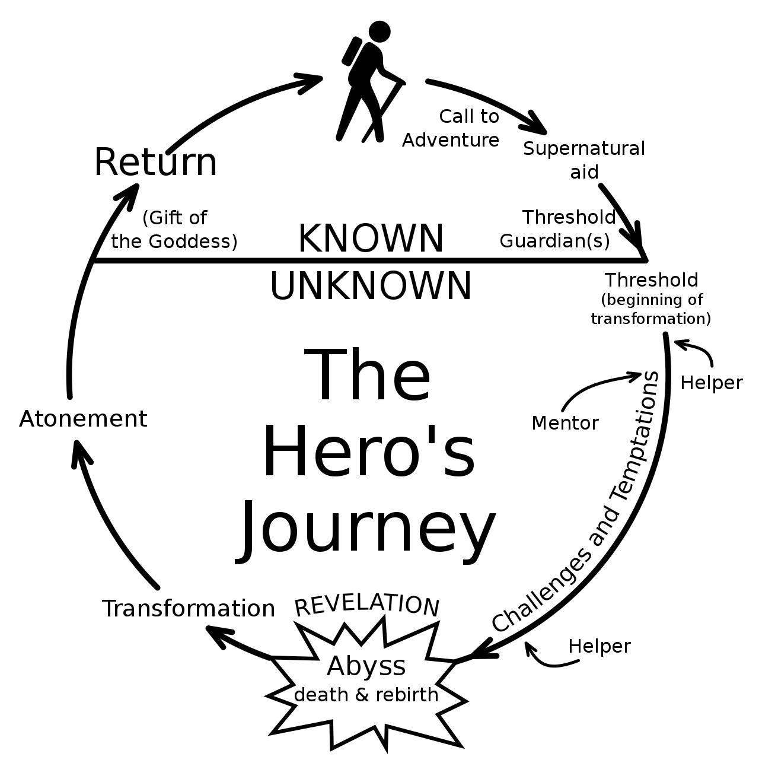

**Step 2: Tell others the story of your podcast**

Introduce your podcast and previous experiences with it to other people based on the hero's journey. Talk about the experiences you've had with your podcasts and what you can learn from each other.

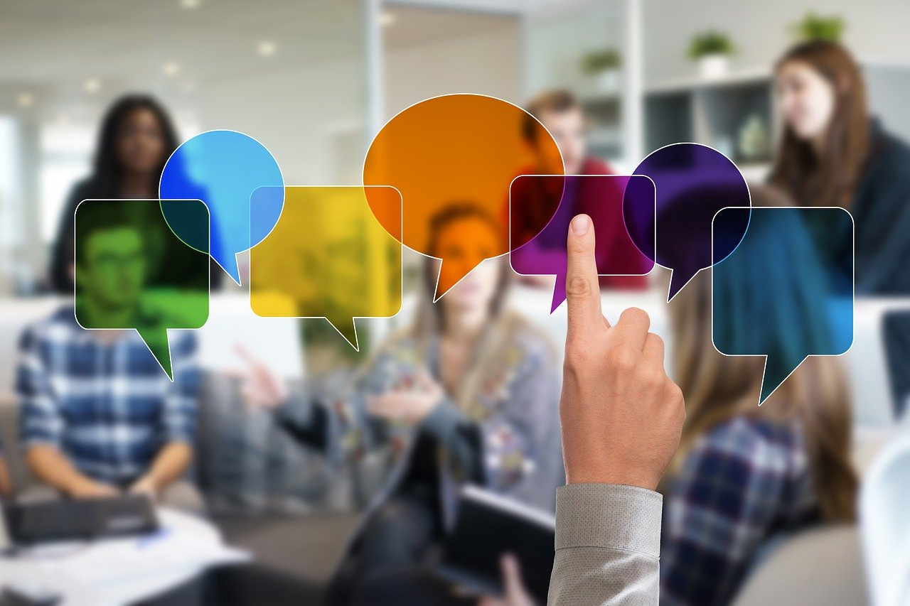

# 4Attendix

## 4.1List of materials

The following material list contains an overview of hardware and software for podcasting with approximate prices (as of research: 28.12.2021, list is sorted alphabetically).

| Hardware/Software | Description | Approx. Price |
| --- | --- | --- |
| Apple EarPod | In-ear headphone cable with built-in microphone, available with 3.5mm jack and Lightning connector | 17,- |
| Behringer HA400 | 4-output headphone amplifier | 25,- |
| Behringer HA8000 | Headphone amplifier with 4 outputs, good for podcast tables | 140,- |
| Behringer U-Phoria UMC204HD | Audio interface, 2 microphone inputs (important: do not use the UMC202HD, as direct monitoring cannot be controlled there) | 79,- |
| Behringer UMC404HD | Audio interface, 4 microphone inputs | 120,- |
| Behringer Xenyx 302USB | USB mixer with 1 microphone and 1 line input | 45,- |
| beyerdynamic DT-297-PV/80 | Hearing-speaking combination (headset), Attention: Cable must be purchased separately | 330,- |
| beyerdynamic DT-770 PRO/80 Ohm | Headphones | 130,- |
| beyerdynamic DT-797 PV | Hearing-talk combination (headset) with integrated cable | 300,- |
| Focusrite Scarlett Solo | Audio interface, 1 microphone and 1 line input | 100,- |
| Focusrite Scarlett 2i2 | Audio interface, 2 microphone inputs | 150,- |
| Focusrite Scarlett 18i20 | Audio interface, 8 microphone inputs, good for podcast tables | 490,- |
| Reaper | Digital Audio Workstation (ultrasonic extension is free), price is for "discounted license", the "commercial license" is more expensive | 60,- |
| RodeCaster Pro | USB mixer with 4 microphone inputs and 4 headphone outputs specifically for podcasting | 500,- |
| Rode NT USB | USB stand microphone with headphone jack (local monitoring) | 140,- |
| Rode PodMic | Cardioid microphone optimized for speech | 100,- |
| Shure SM 7B | Studio Microphone | 370,- |
| Sony MDR-7506 | Headphones | 100,- |
| Superlux HMC 660 X | Hearing-talk combination (headset), Attention: operate with maximum 12V phantom power (not 48V), can be set with zoom audio recorders | 50,- |
| Termichy Bluetooth Headphones | Bluetooth headphones that can also be used on a 3.5mm jack cable (e.B. for microphone V-Moda BoomPro) | 25,- |
| V-Moda BoomPro | Microphone cable that can be plugged into headphones with a 3.5mm jack , Attention: do not buy V-Moda BoomPro X | 30,- |
| Yamaha AG03 | USB mixer with 1 microphone and 1 line input | 120,- |
| Yamaha AG03 | USB mixer with 2 microphone and 1 line inputs | 160,- |
| Zoom H5 | Audio recorder (4 channels) | 230,- |
| Zoom H6 | Audio recorder (6 channels) | 330,- |
| Zoom LiveTrak L-12 | USB mixer with 8 microphone and 2 line inputs and 5 headphone outputs | 530,- |

## 4.2Thanks

I would like to take this opportunity to thank all [employees of the Fraunhofer Institute for Integrated Circuits](https://www.iis.fraunhofer.de) (IIS) who brought me into contact with audio coding and the MP3 standard during my active time there from the mid-1990s. I would also like to thank the German-speaking podcasting community around the [Sendegate](https://sendegate.de), as I was able to learn a lot about podcasting through the forum and events such as subscribe. My special thanks go to Tim Pritlove, who with his article [Podcasting for Beginners](http://pb21.de/2011/05/podcasting-fur-einsteiger-1) on pb21.de (CC BY), first formed the basis for the Wikibook [Podcasting for beginners and advanced](https://de.wikibooks.org/wiki/Podcasting_f%C3%BCr_Einsteiger_und_Fortgeschrittene) and then also for this guide. I would also like to thank Marco Hitschler, from whose Sketchnote [Podcast in a Nutshell](https://www.unmus.de/podcast-in-a-nutshell) (CC BY) I used excerpts for the illustration of this guide.

## 4.3Change history

| Version | Edited by | Description Change | Date |
| --- | --- | --- | --- |
| 0.1 | Simon Dückert | Initial version created, content taken from the Wikibook, chapter preface created, chapter acknowledgement created, chapter introduction created, rudimentary version of the katas created, literature and link list updated. | 24.03.2019 |
| 0.2 | Simon Dückert | Parts of the sketch note "Podcast in a Nutshell" by Marco Hitschler (@zirkusliebe) taken over as illustrations of the chapters. | 27.07.2019 |
| 0.3 | Simon Dückert | Table of contents adapted to lernOS High Level Structure, subtitles added, chapter "Podcasting basic equipment" renamed to "Podcasting Hardware". | 29.12.2019 |
| 0.4 | Simon Dückert | Web presentation added, link to ultrasound tutorial added | 27.12.2021 |
| 0.5 | Simon Dückert | Feedback from rc3 added | 29.12.2021 |
| 0.9 | Simon Dückert | Katas extended in the learning path (was previously only a list) | 27.02.20212 |